Aravind G Kumar

AWS advanced course Assignment

**PROJECT 1: WINDOWS IIS**

STEP 1: Creating a windows instance.

In this process to create an instance is as follows:

* Choose the AMI for the instance, so here we choose Microsoft windows server 2019
* Then choose the instance type. As we are on trial account, we will be using free tier options only. So that go with General purpose with t2 micro type.
* Configure instance details and here as of now we will be using the settings as default.
* Add storage and here we will be using a General-purpose SSD with 30 GiB storage as the root volume.
* Add tags, in this step we will be adding tags or specific name to identify the instances in the cluster of instances in a working environment.
* Configure Security Group, where you can add rules to allow specific traffic to reach your instance.
* Finally review and launch the instance and wait for the 2/2 checks

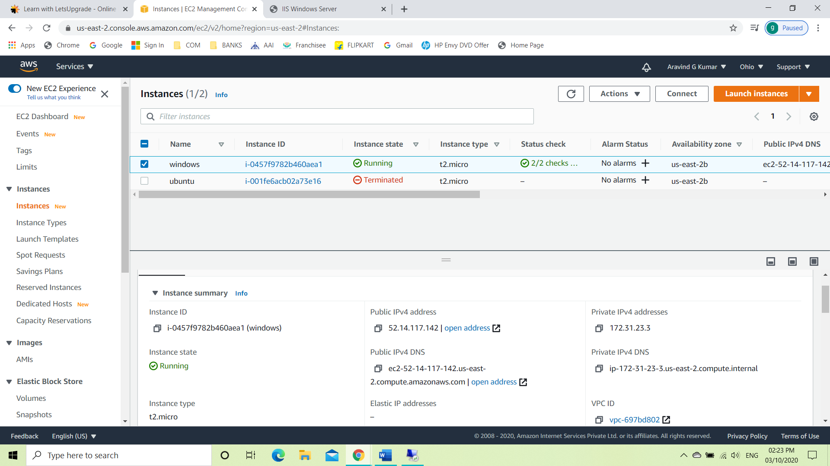

STEP 2: Launch Windows instance using RDP.

After the instance is created, we connect the instance using RDP client. Then we decrypt the password with the keypair we have. Then we launch the machine and use windows PowerShell ISE to connect to the instance.

The code we use to do the connection is mentioned below:

Install-WindowsFeature -name Web-Server –IncludeManagementTools

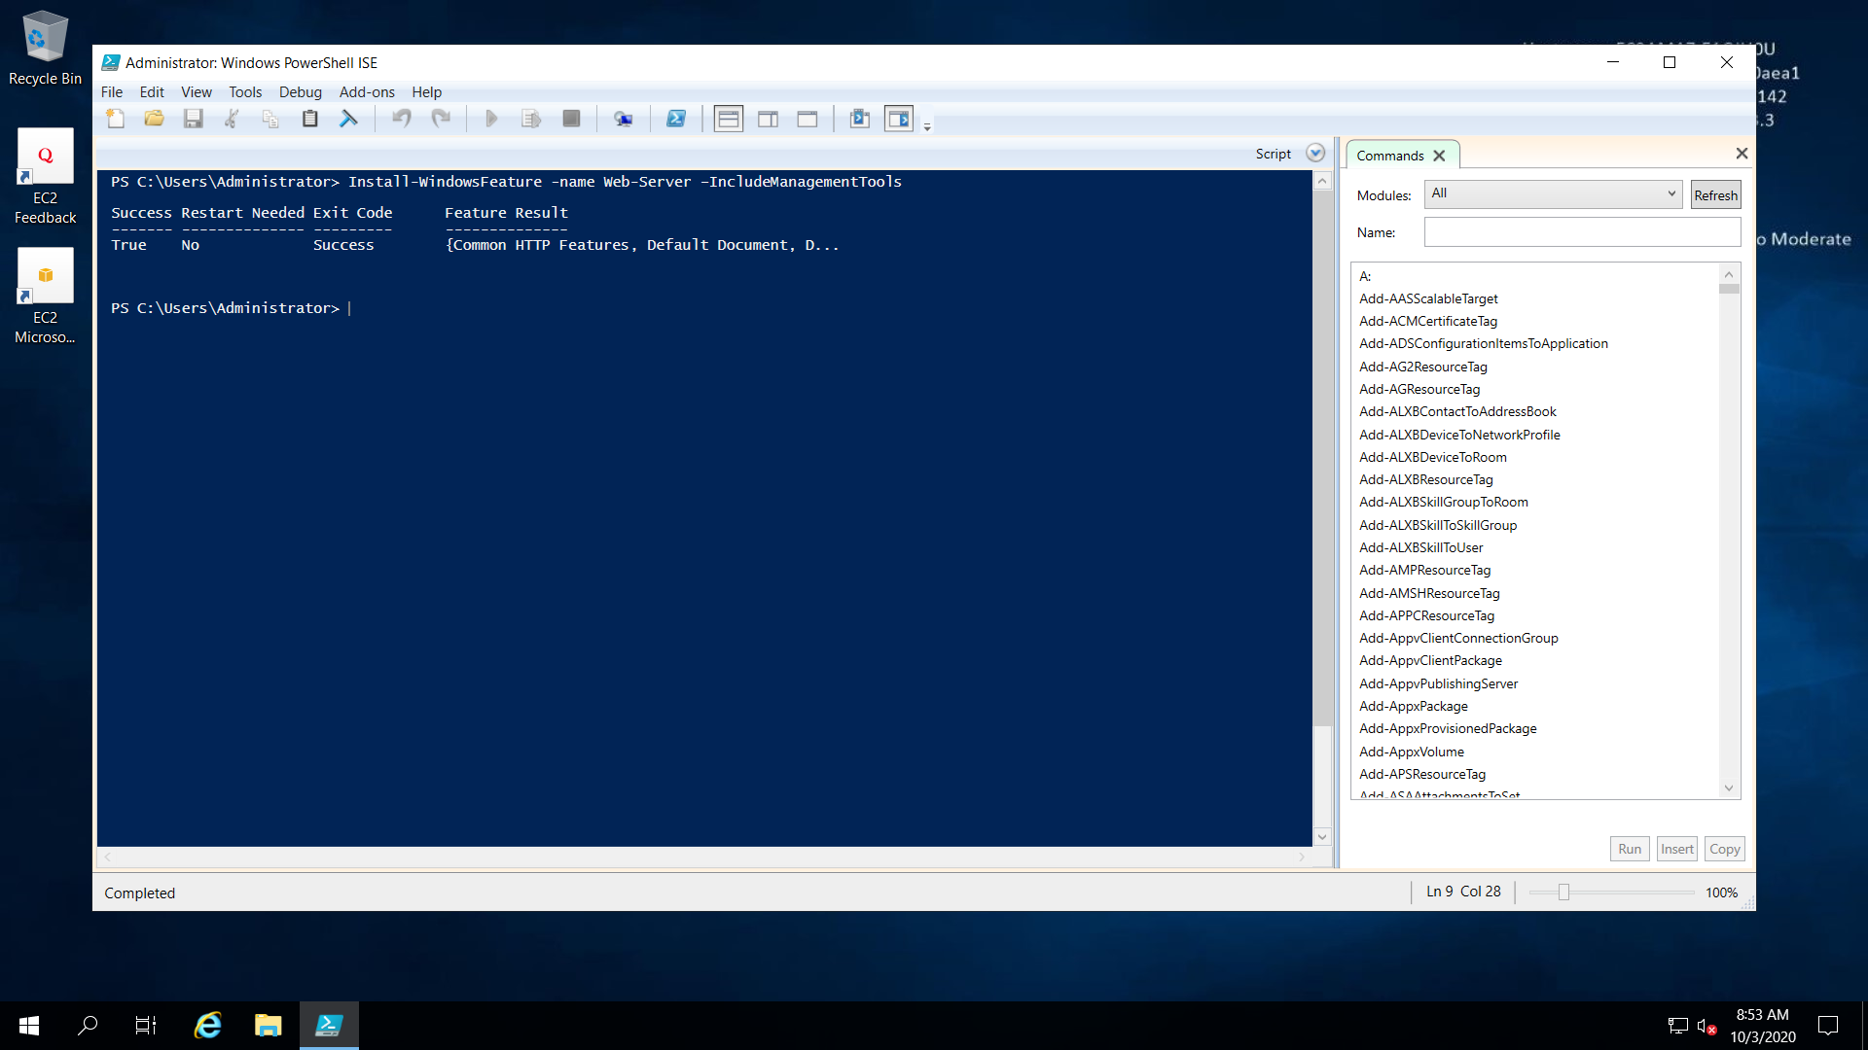

STEP 3: Connecting to ISS windows server.

In this step we will be copying the Public IPv4 to connect to the

ISS Windows Server.

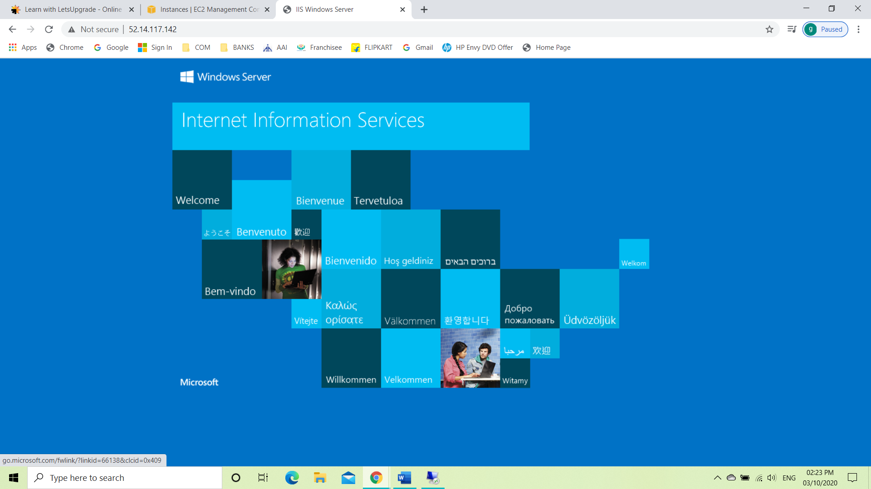

**PROJECT 2: NGINX**

STEP 1: Creating an ubuntu instance.

In this process to create an instance is as follows:

* Choose the AMI for the instance, so here we choose Ubuntu server.
* Then choose the instance type. Here we go with General purpose with t2 micro type.
* Configure instance details and here as of now we will be using the settings as default.
* Add storage and here we will be using a General-purpose SSD with 8 GiB storage as the root volume.
* Add tags, in this step we will be adding tags or specific name to identify the instances in the cluster of instances in a working environment.
* Configure Security Group, where you can add rules to allow specific traffic to reach your instance.
* Finally review and launch the instance and wait for the 2/2 checks

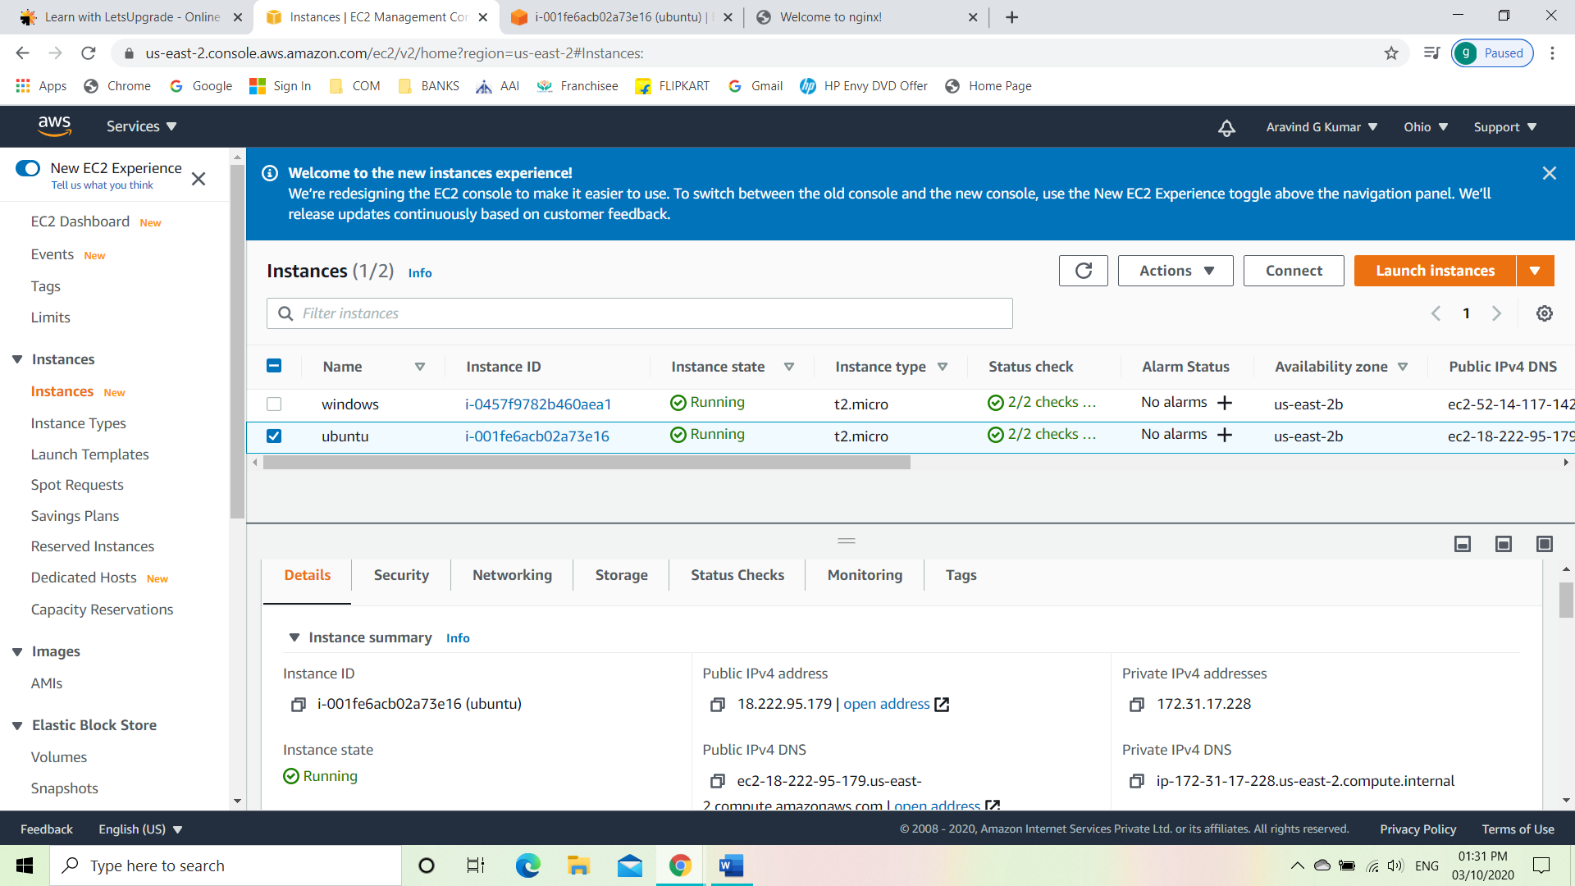

STEP 2: Connecting the instance.

After the instance is created, we connect the instance using EC2 instance connect. The codes to connect the instance will be stated below:

 sudo apt-get -y update

 sudo apt-get -y install nginx

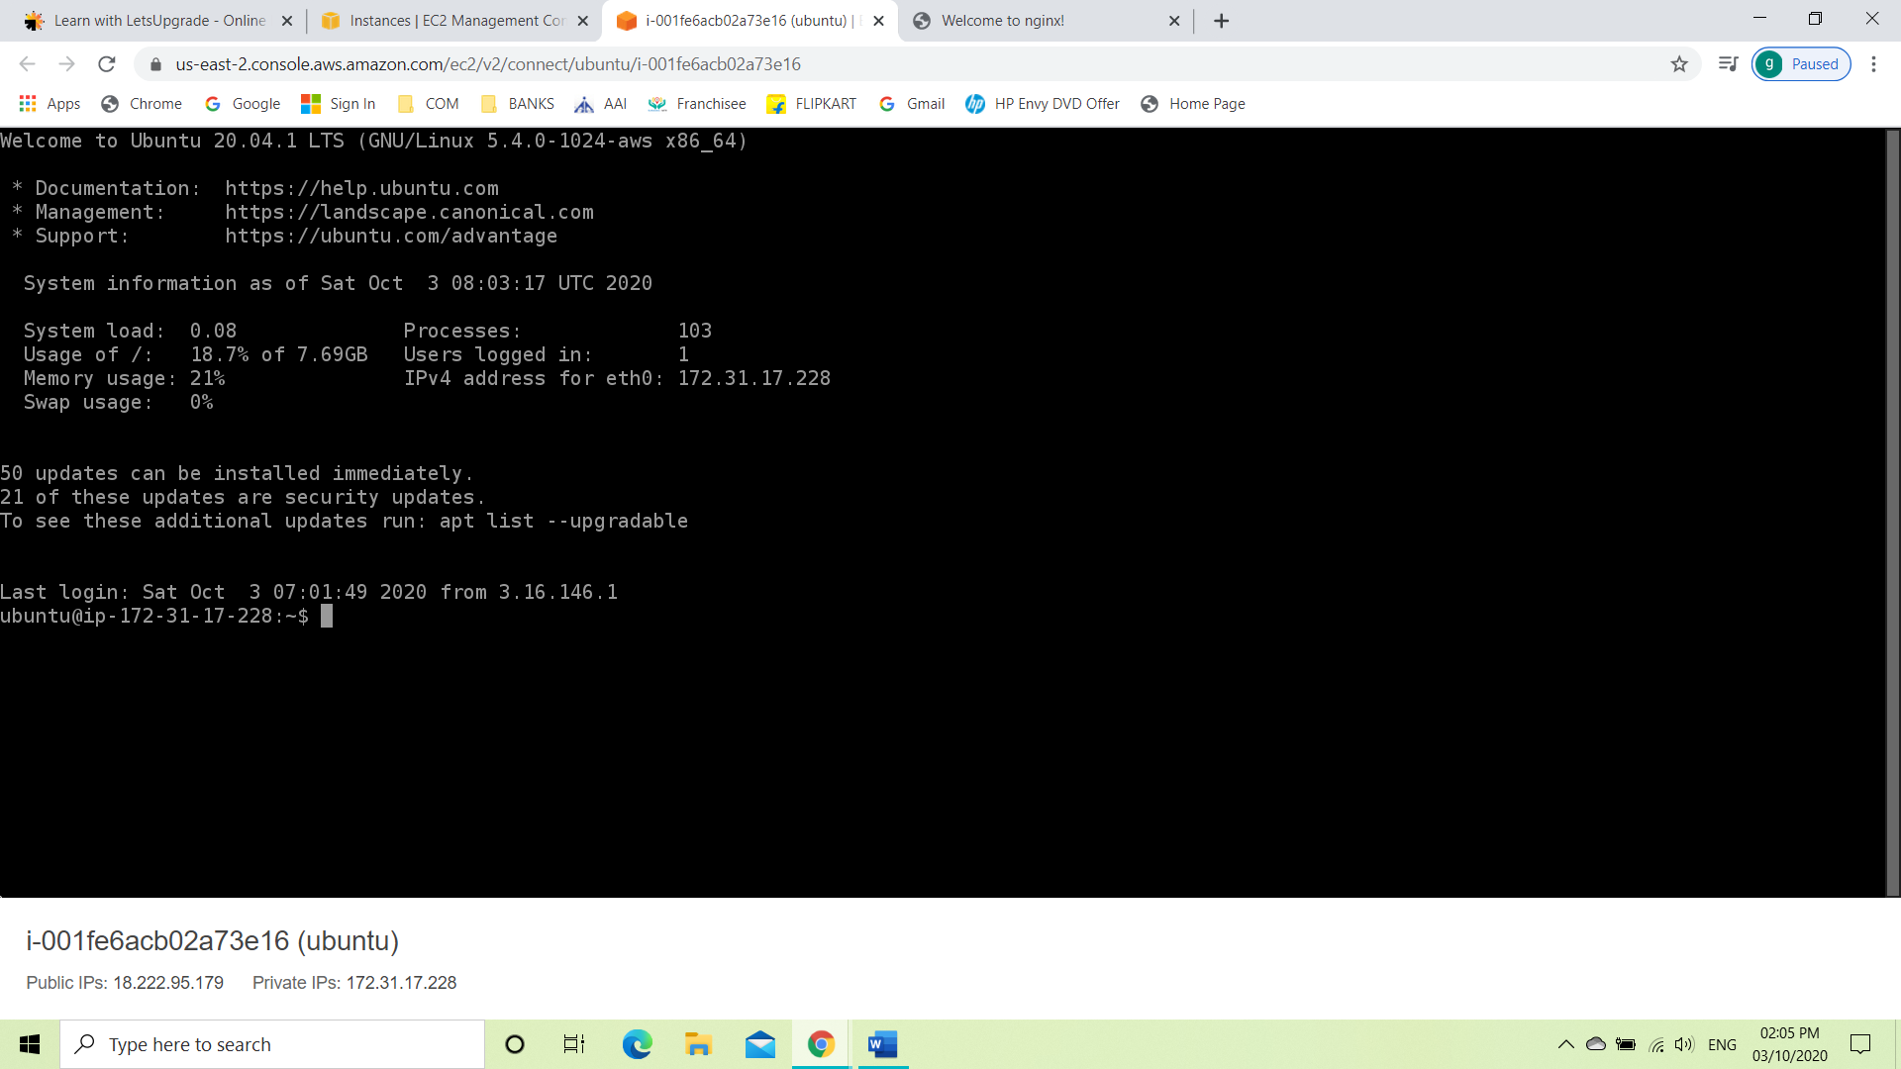

STEP 3: Connecting to NGINX.

In this step we will be copying the Public IPv4 to connect to the

Nginx web server.

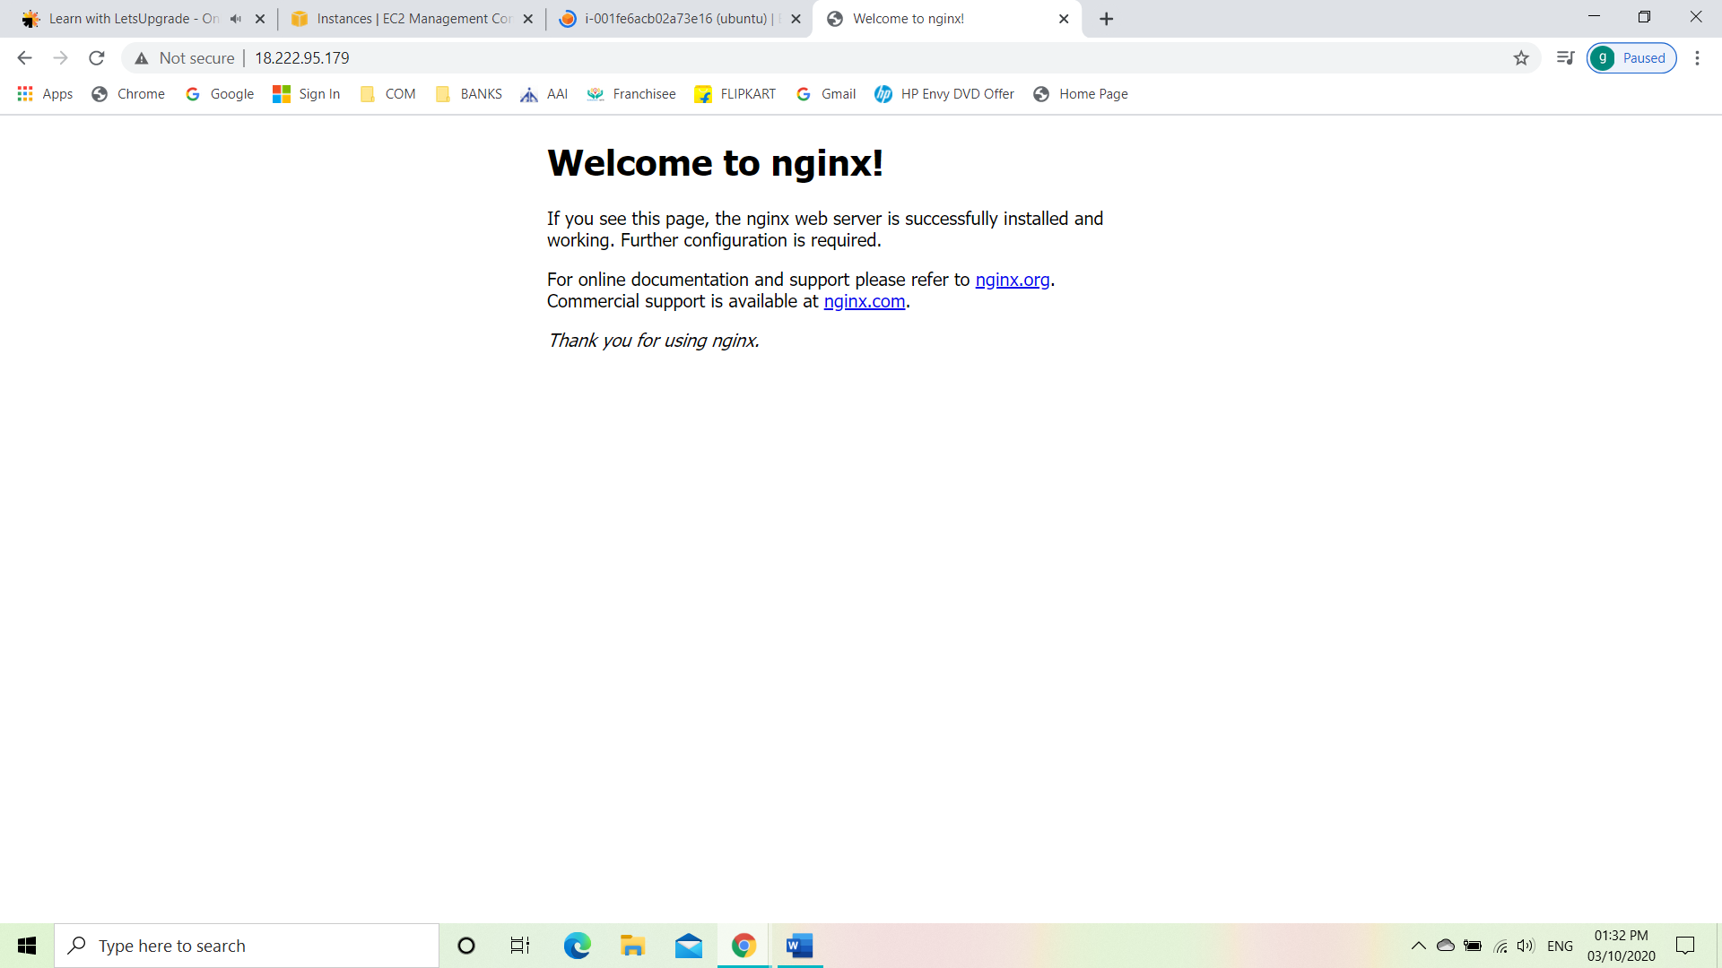

**PROJECT 3: ELASTIC BLOCK STORAGE [ EBS]**

STEP 1: Creating a windows machine.

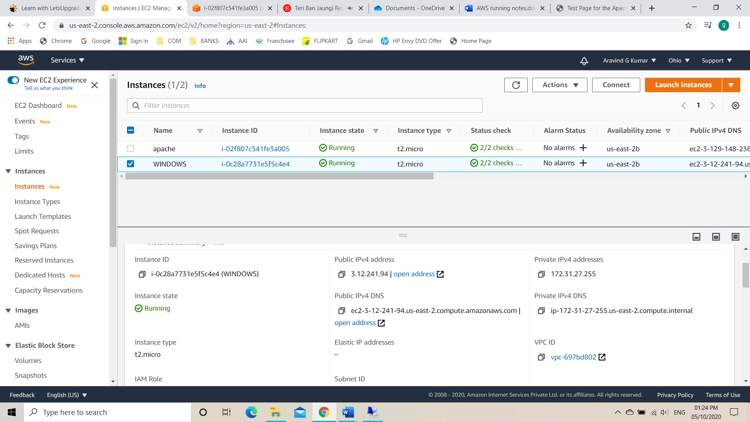

STEP 2: Creating an EBS volume.

To create a volume, go to Elastic Block Storage and click on volumes. Then go for create volume. While creating the volume check on the availability zone of the machine we are planning to mount the new volume and assign accordingly.

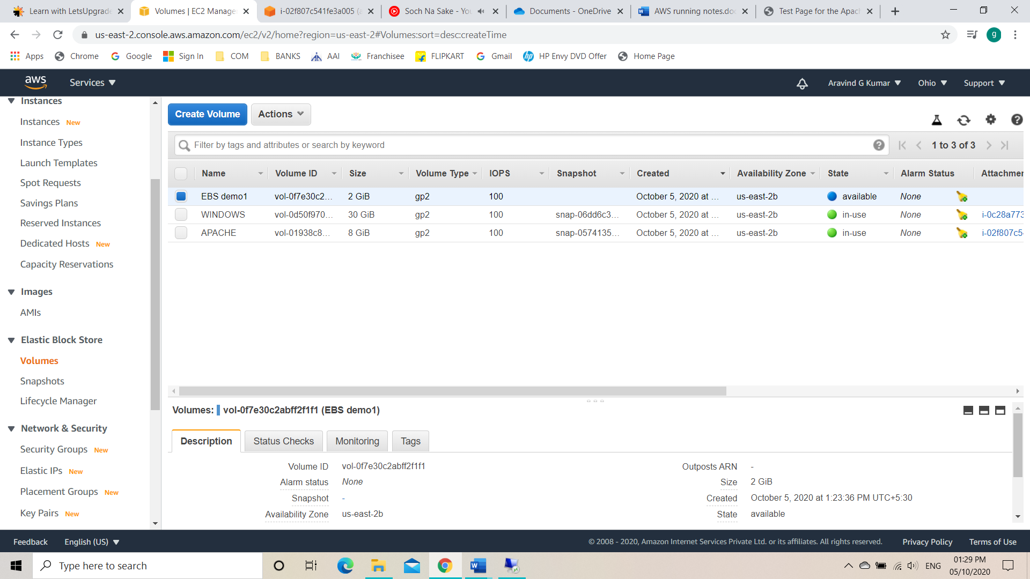

STEP 3: Attaching the newly created EBS volume to windows instance volume.

Click on the newly created volume and click on attach volume. Select the instance which we want to mount the newly created EBS volume.

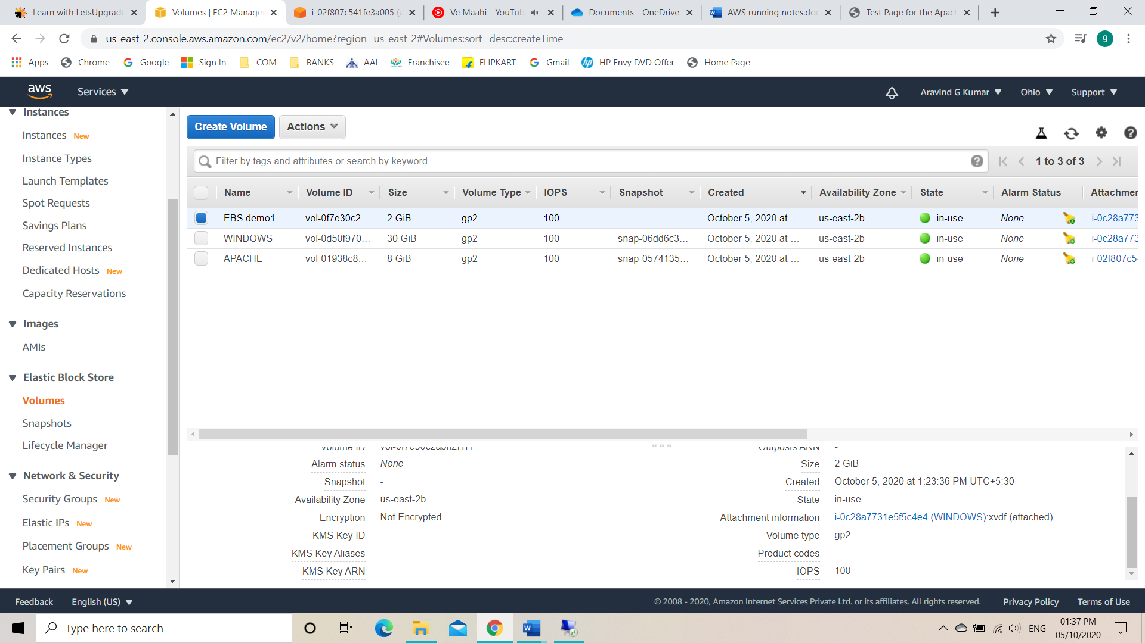

STEP 4: Connecting to the instance using RDP client.

Connect the instance using RDP client. Then we decrypt the password with the keypair we have. Then we launch the machine and use windows Service Manager.

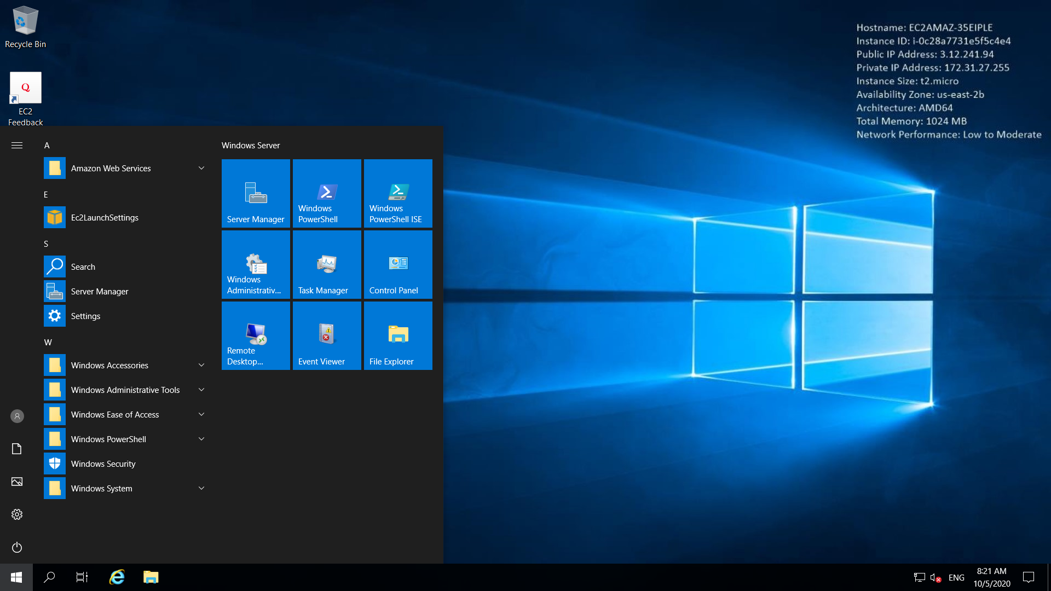

STEP 5: Mounting the disk into the original machine.

* After selecting the server manager, wait for the machine to connect.
* Then go to File and Storage services and click on volume where we will be able to find disks.
* Bring the EBS volume online by right click and select bring volume online.
* Then right click new volume and proceed with the next steps with default and create.
* Now we can see volume has been mounted.

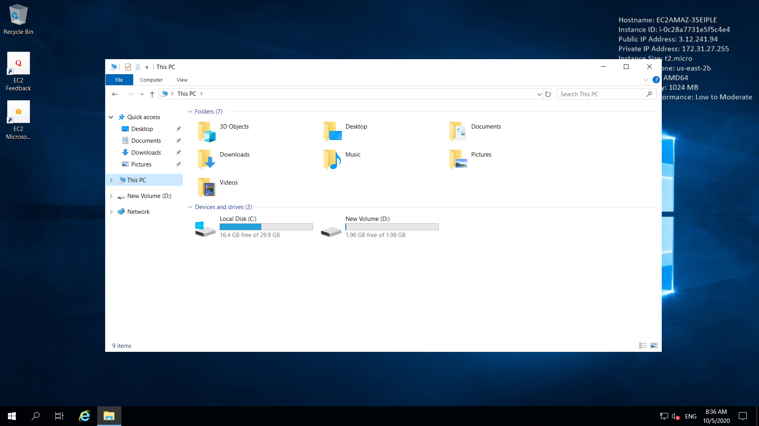

STEP 6: Detaching the newly created volume.

* Go to EBS and select volume
* Select the newly created volume
* Then detach the volume
* Finally delete the volume
* As a result, the attached new volume in the machine will be removed.

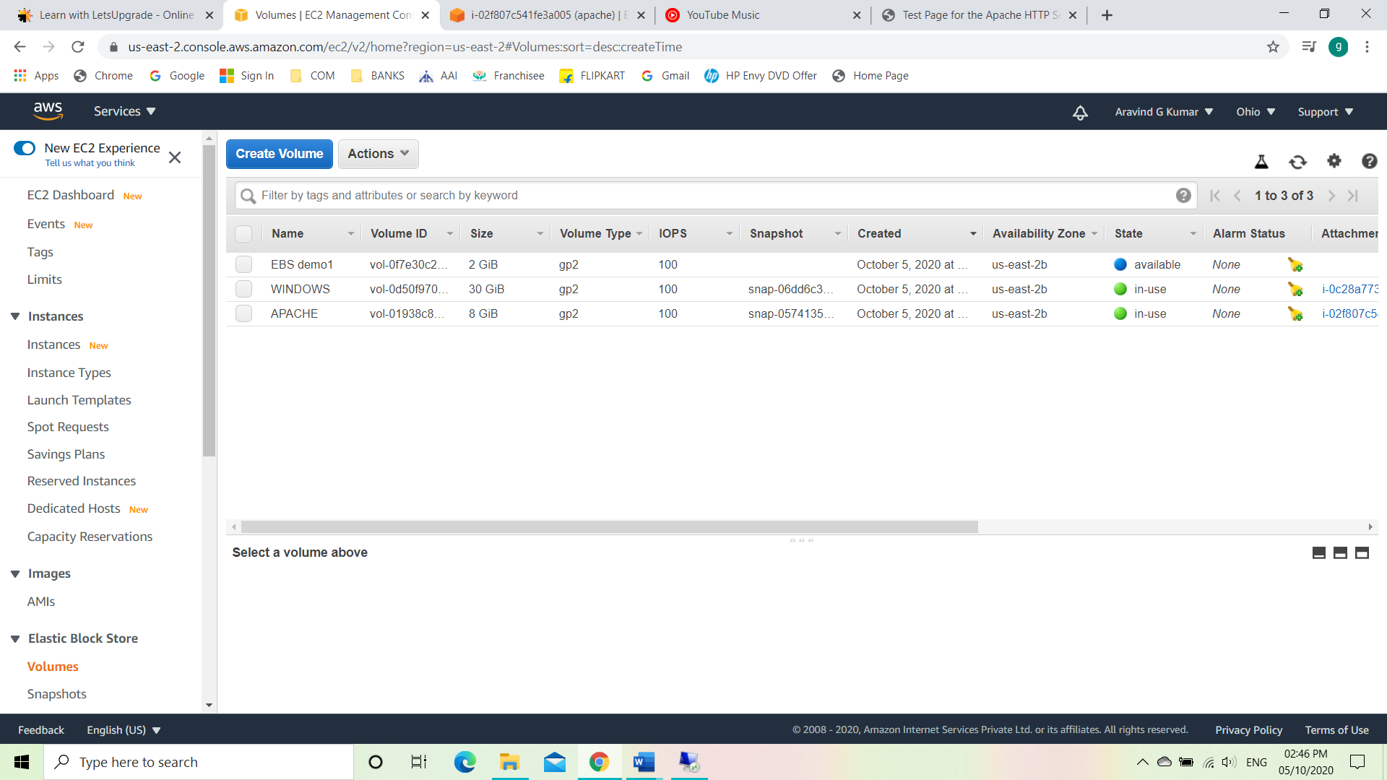

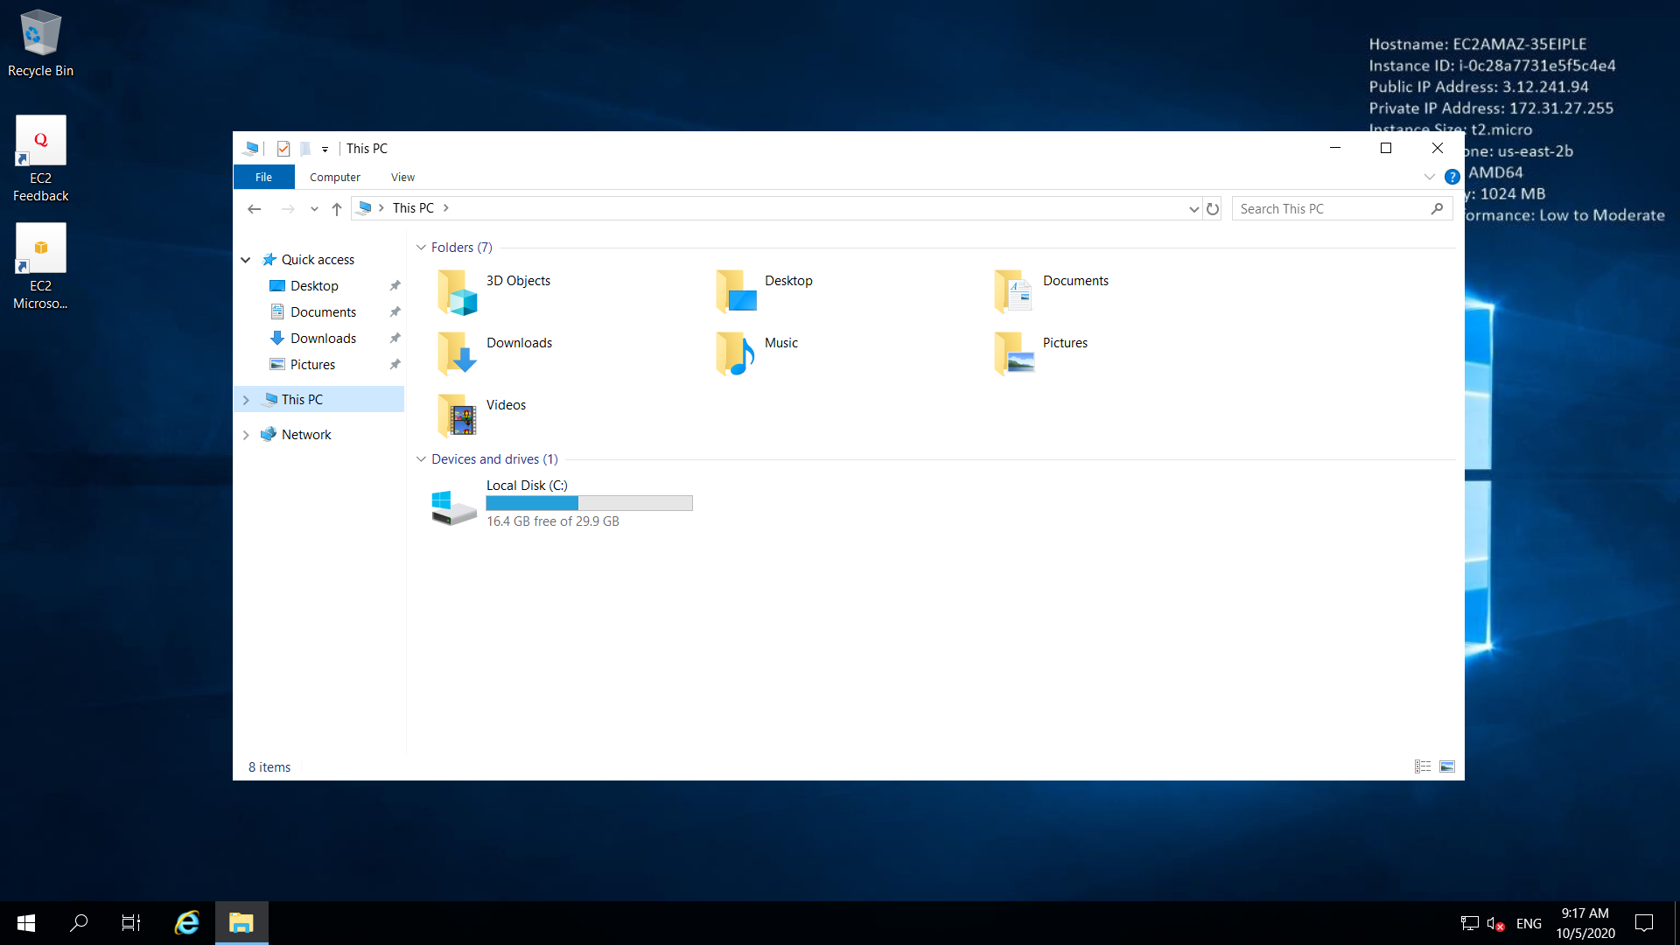

**PROJECT 4: Elastic IPs**

STEP 1: Install an APACHE server.

In this process to create an instance is as follows:

* Choose the AMI for the instance, so here we choose Amazon Linux 2 AMI.
* Then choose the instance type. Here we go with General purpose with t2 micro type.
* Configure instance details and here as of now we will be using the settings as default.
* Add storage and here we will be using a General-purpose SSD with 8 GiB storage as the root volume.
* Add tags, in this step we will be adding tags or specific name to identify the instances in the cluster of instances in a working environment.
* Configure Security Group, where you can add rules to allow specific traffic to reach your instance.
* Finally review and launch the instance and wait for the 2/2 checks

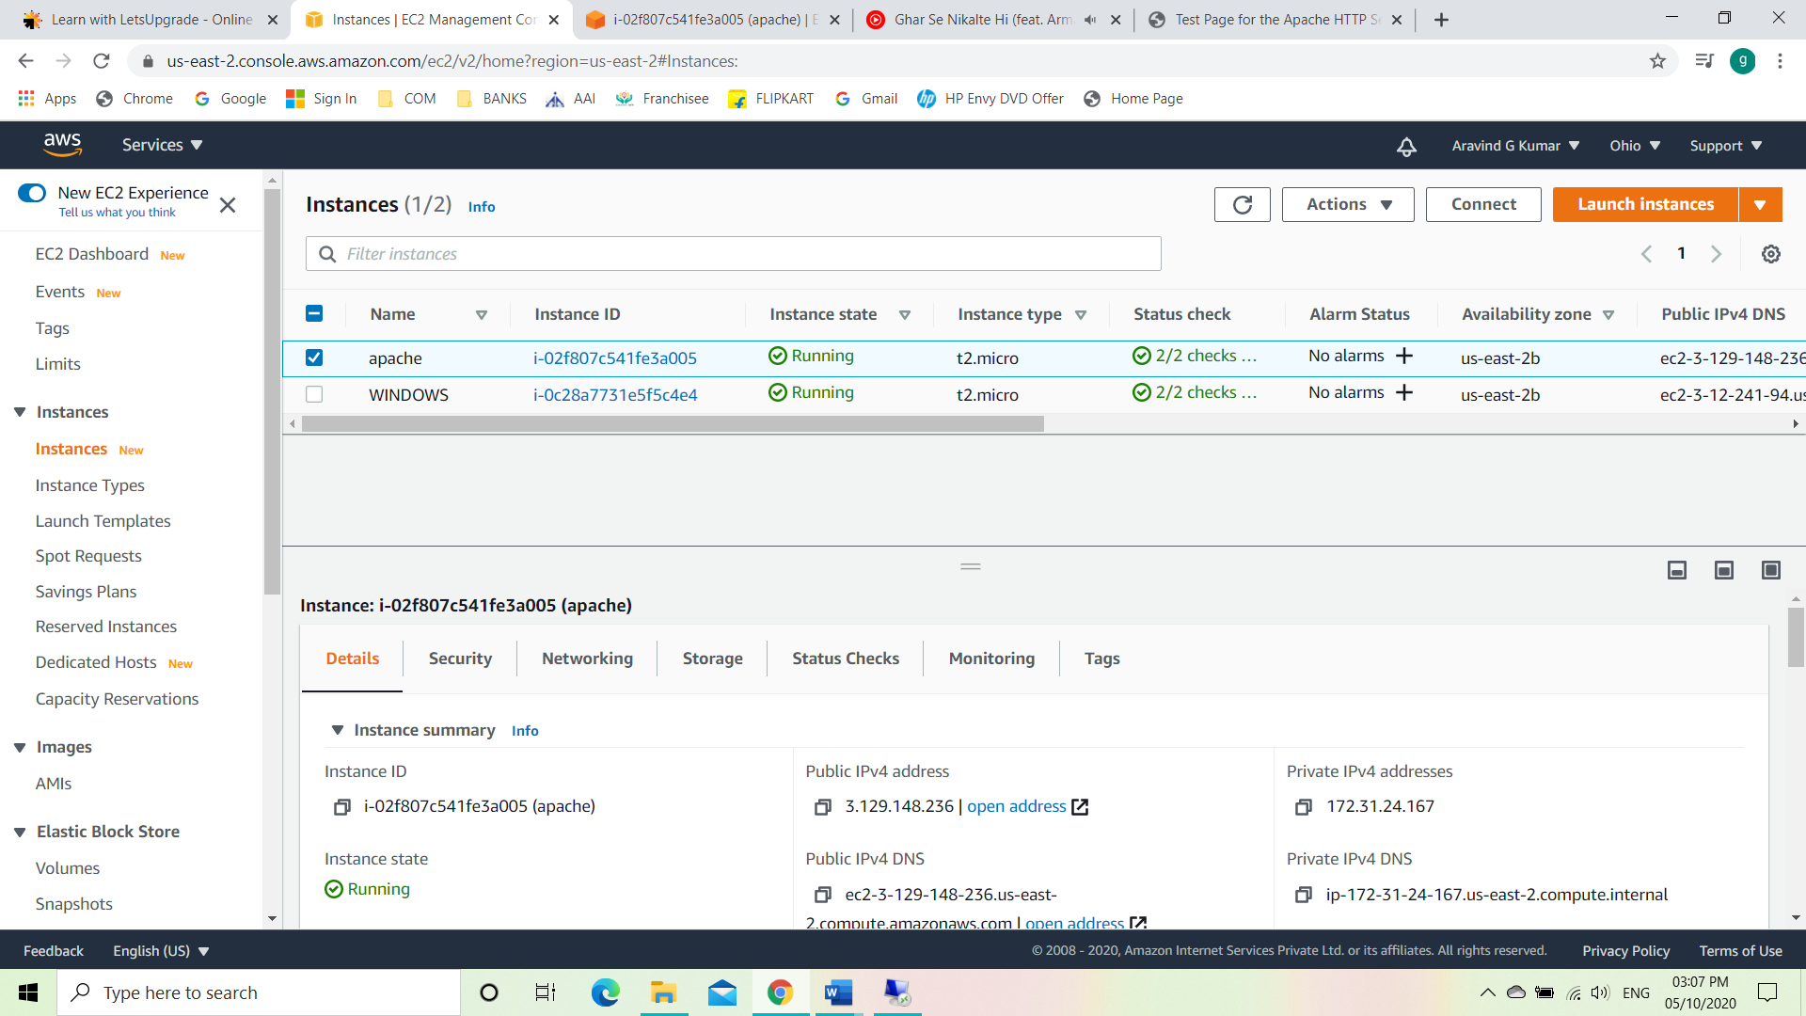

STEP2: Connecting the instance.

For this process we will be using the EC2 Instance Connect.

The codes to connect the Instance will be as follows:

sudo -s

sudo su

yum -y update

yum install httpd

When prompted, press “Y” to confirm

systemctl start httpd

systemctl enable httpd

systemctl status httpd

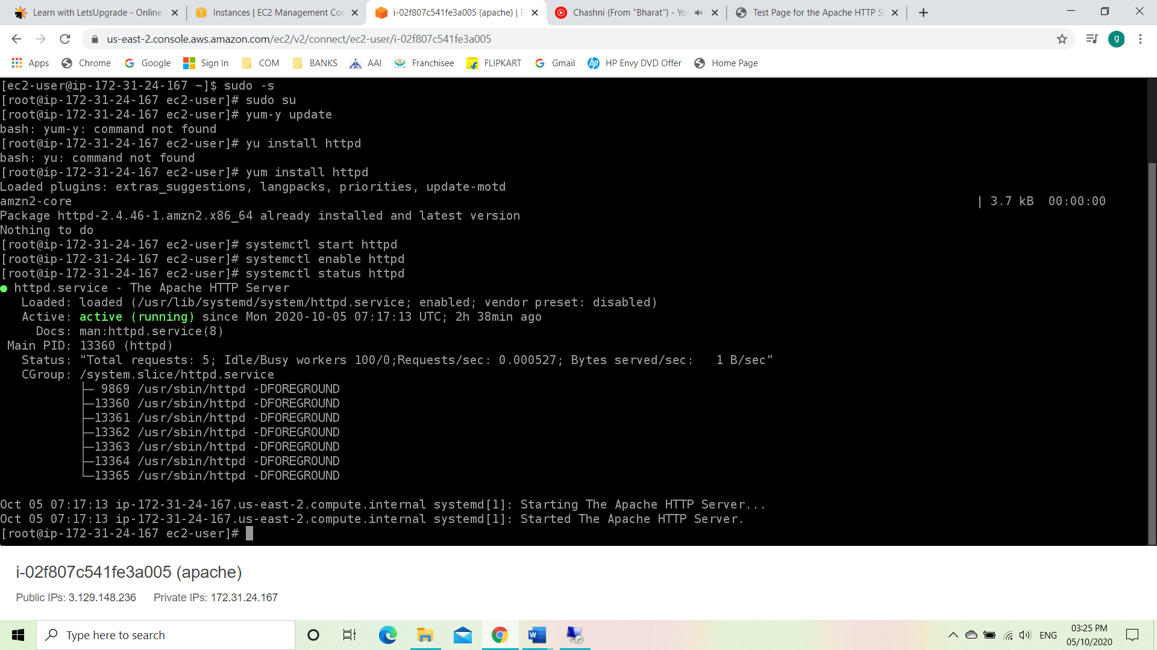

STEP3: Connecting to APACHE server.

In this step we will be copying the Public IPv4 to connect to the

Apache web server.

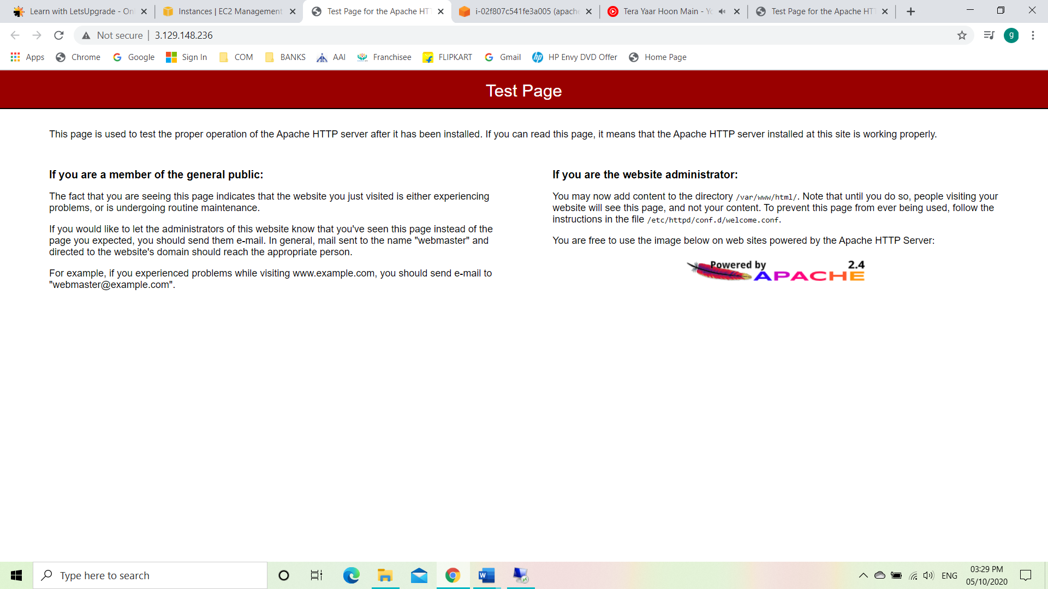

STEP 4: Allocating IP Address

In this step we will be creating a new IP.

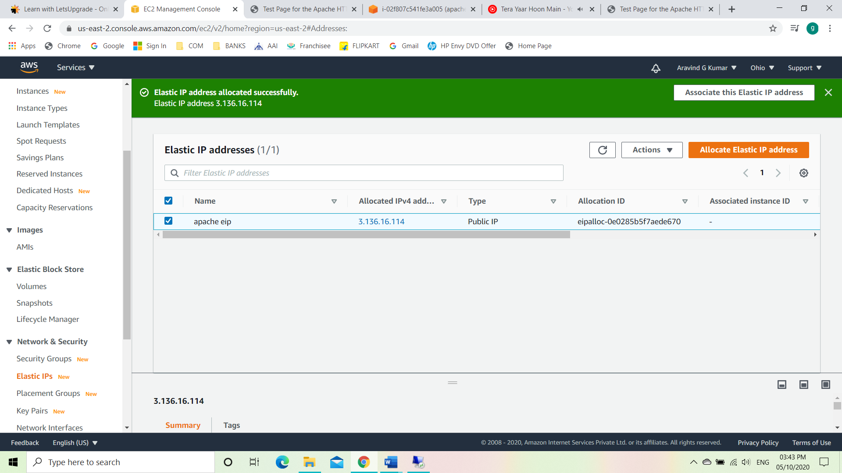

Now we will be associating it to an existing instance.

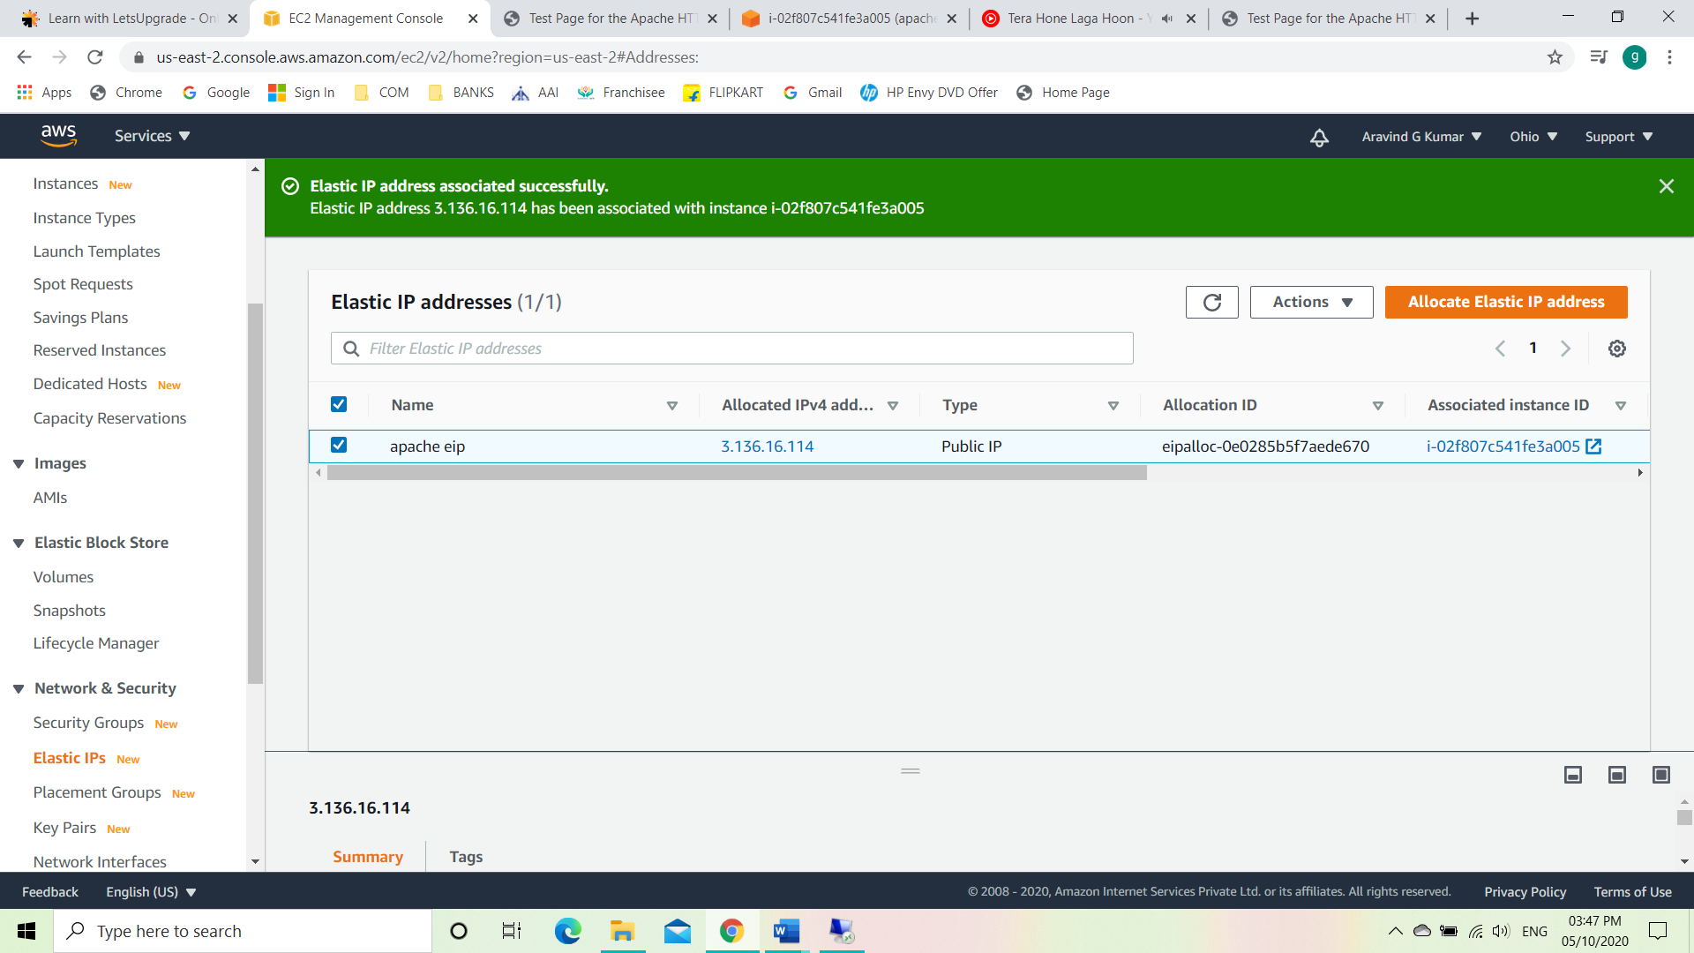

STEP 5: Connecting the Instance with newly created IP address.

As the new elastic IP has been created the old IP 3.129.148.236 won’t be getting redirected.

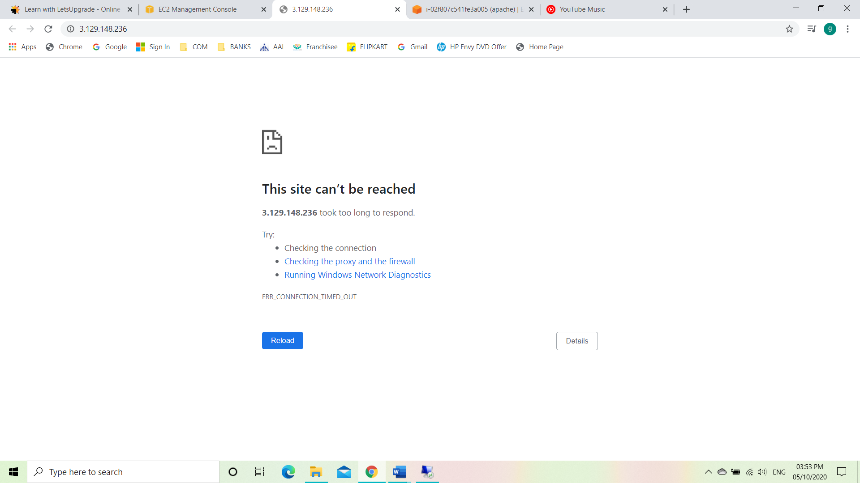

Now using the elastic IP we created, will be used to launch the APACHE server this time.

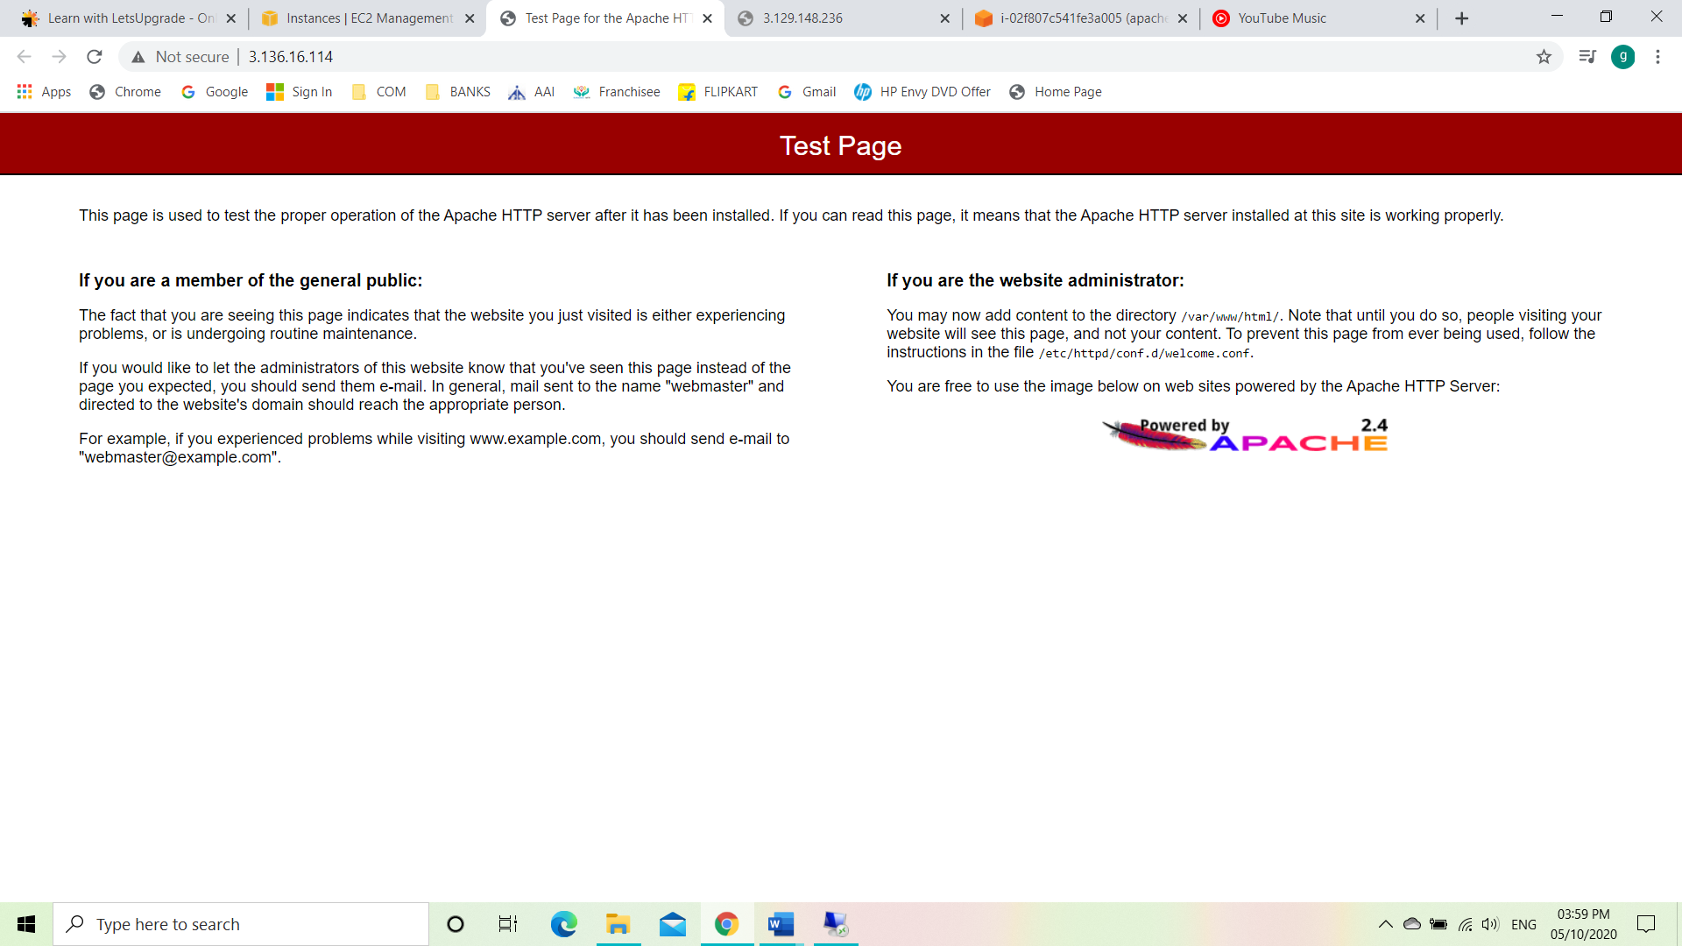

**PROJECT 5: Working with S3**

1. **Working with S3 .jpg**

STEP 1: Creating a S3 bucket

To create a bucket, follow the steps:

* Go to AWS web console service menu and select S3.
* After selecting S3, we will be seeing the buckets page.
* Click on create volume.
* After creating a volume add a file to the bucket.

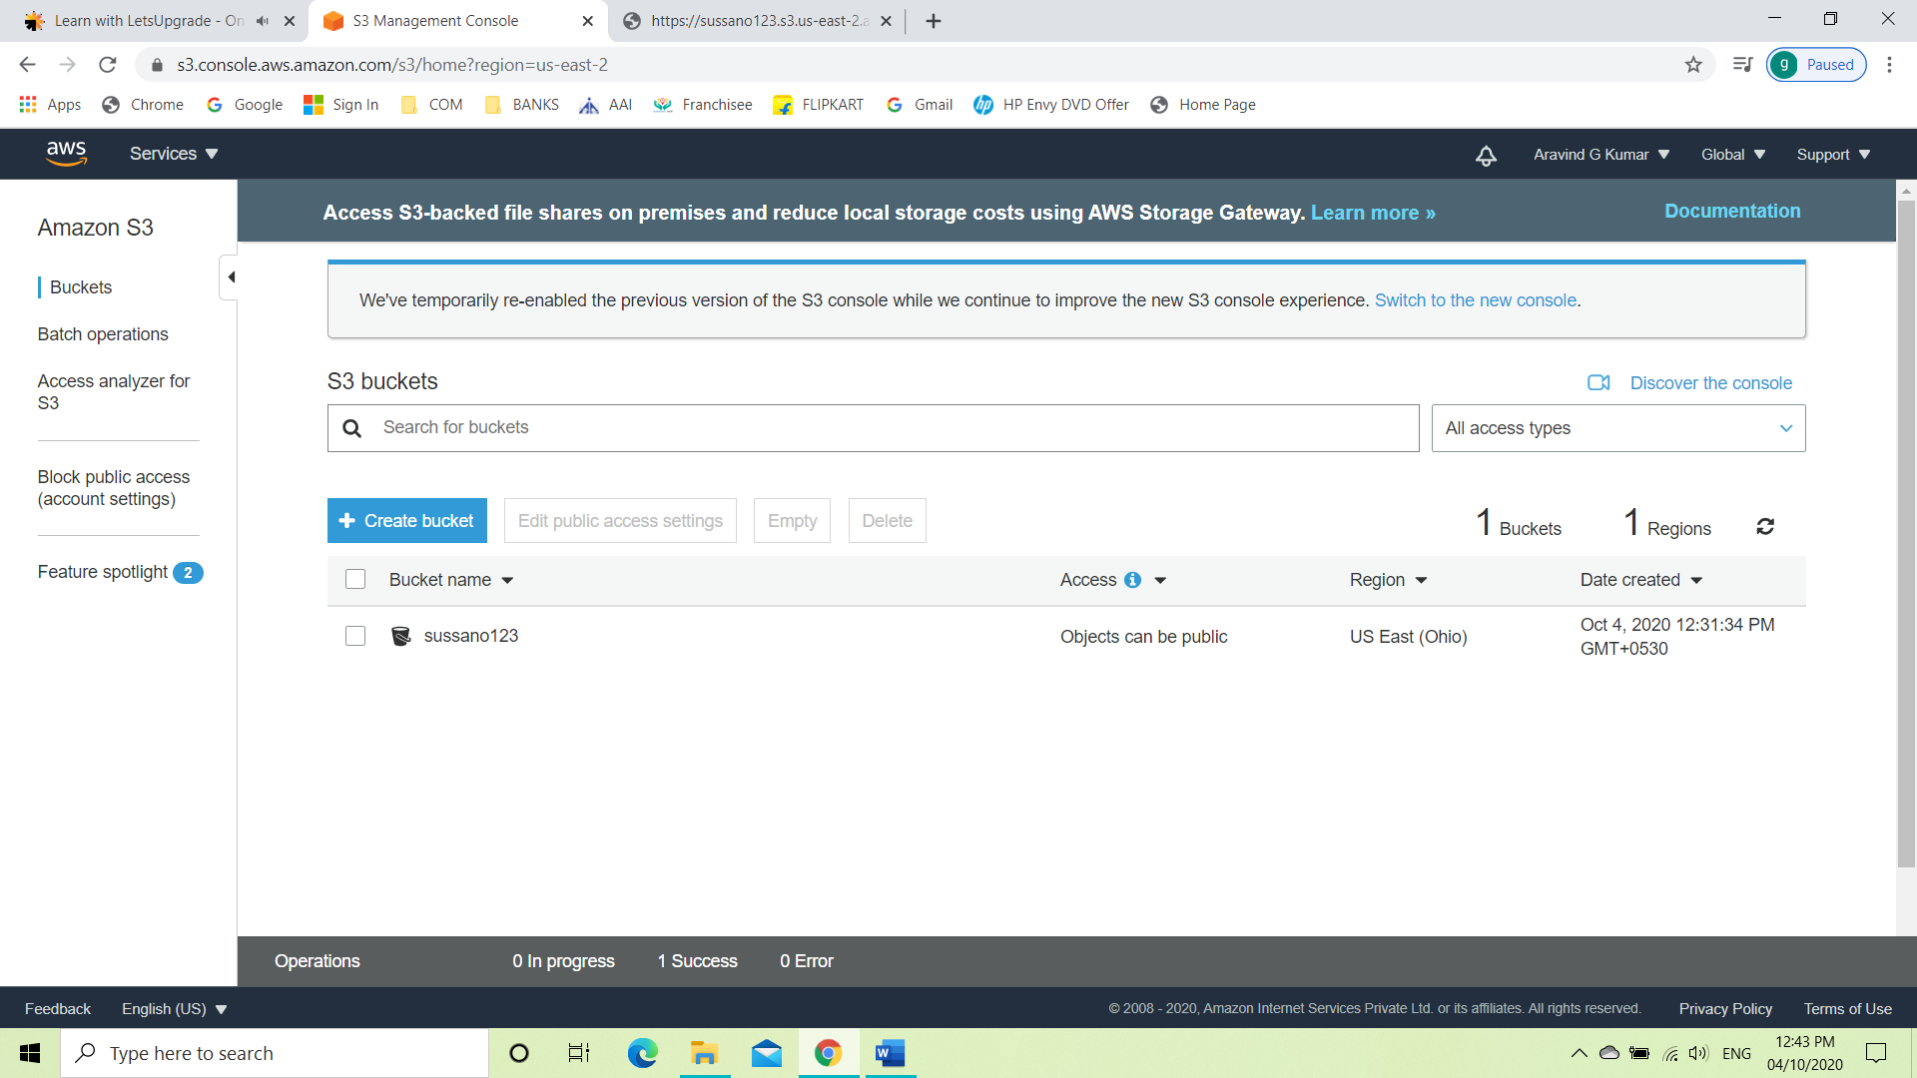

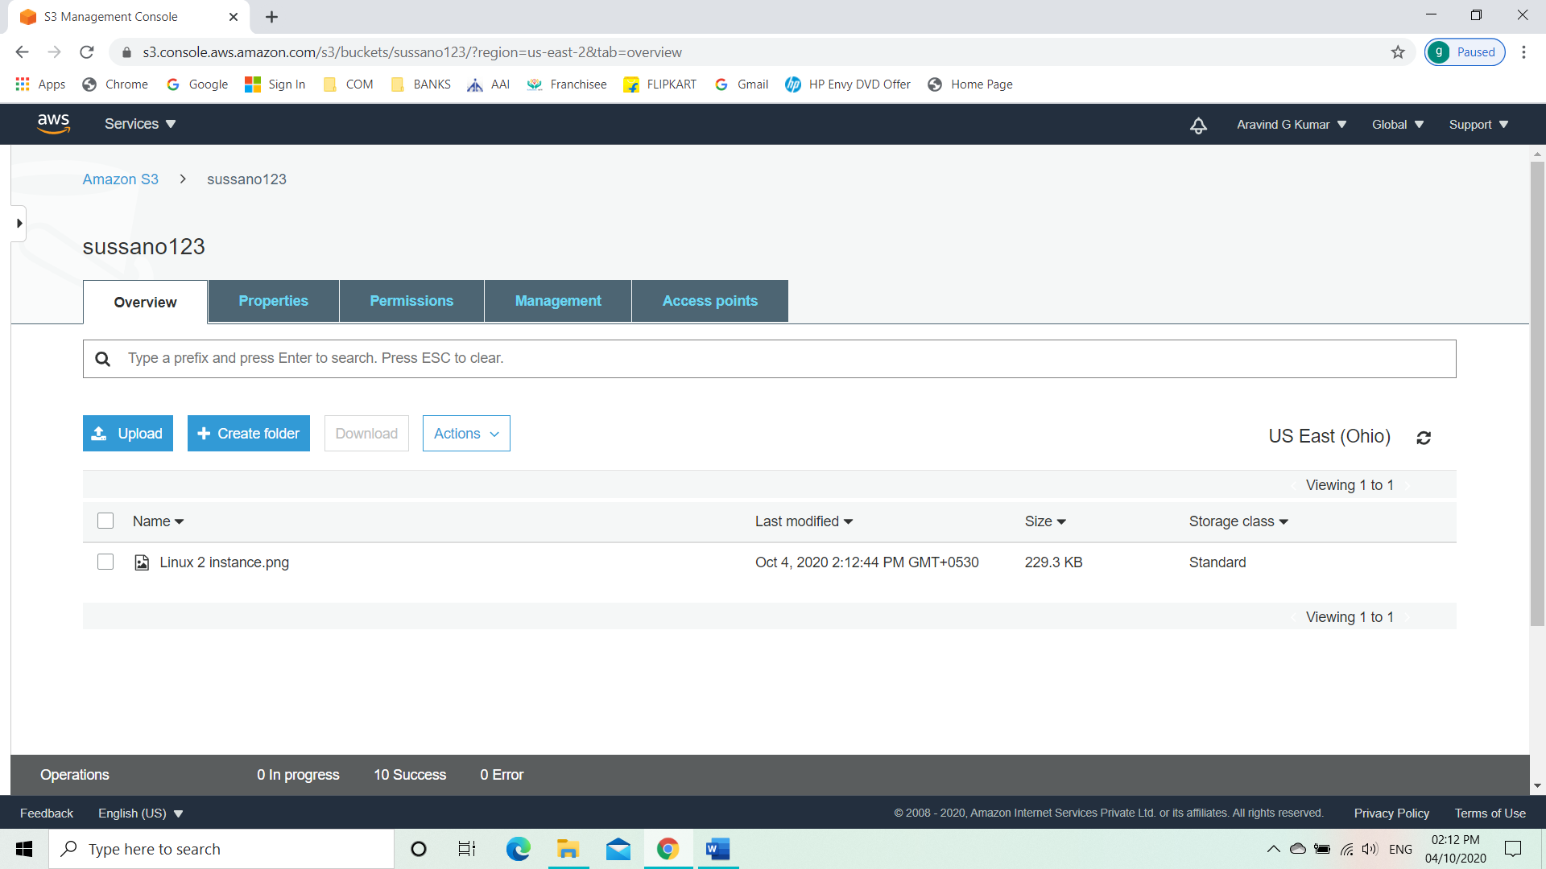

STEP 2: Making the bucket public

To make the bucket public

* First check the bucket is public or not.
* Go to overview and click on object URL.

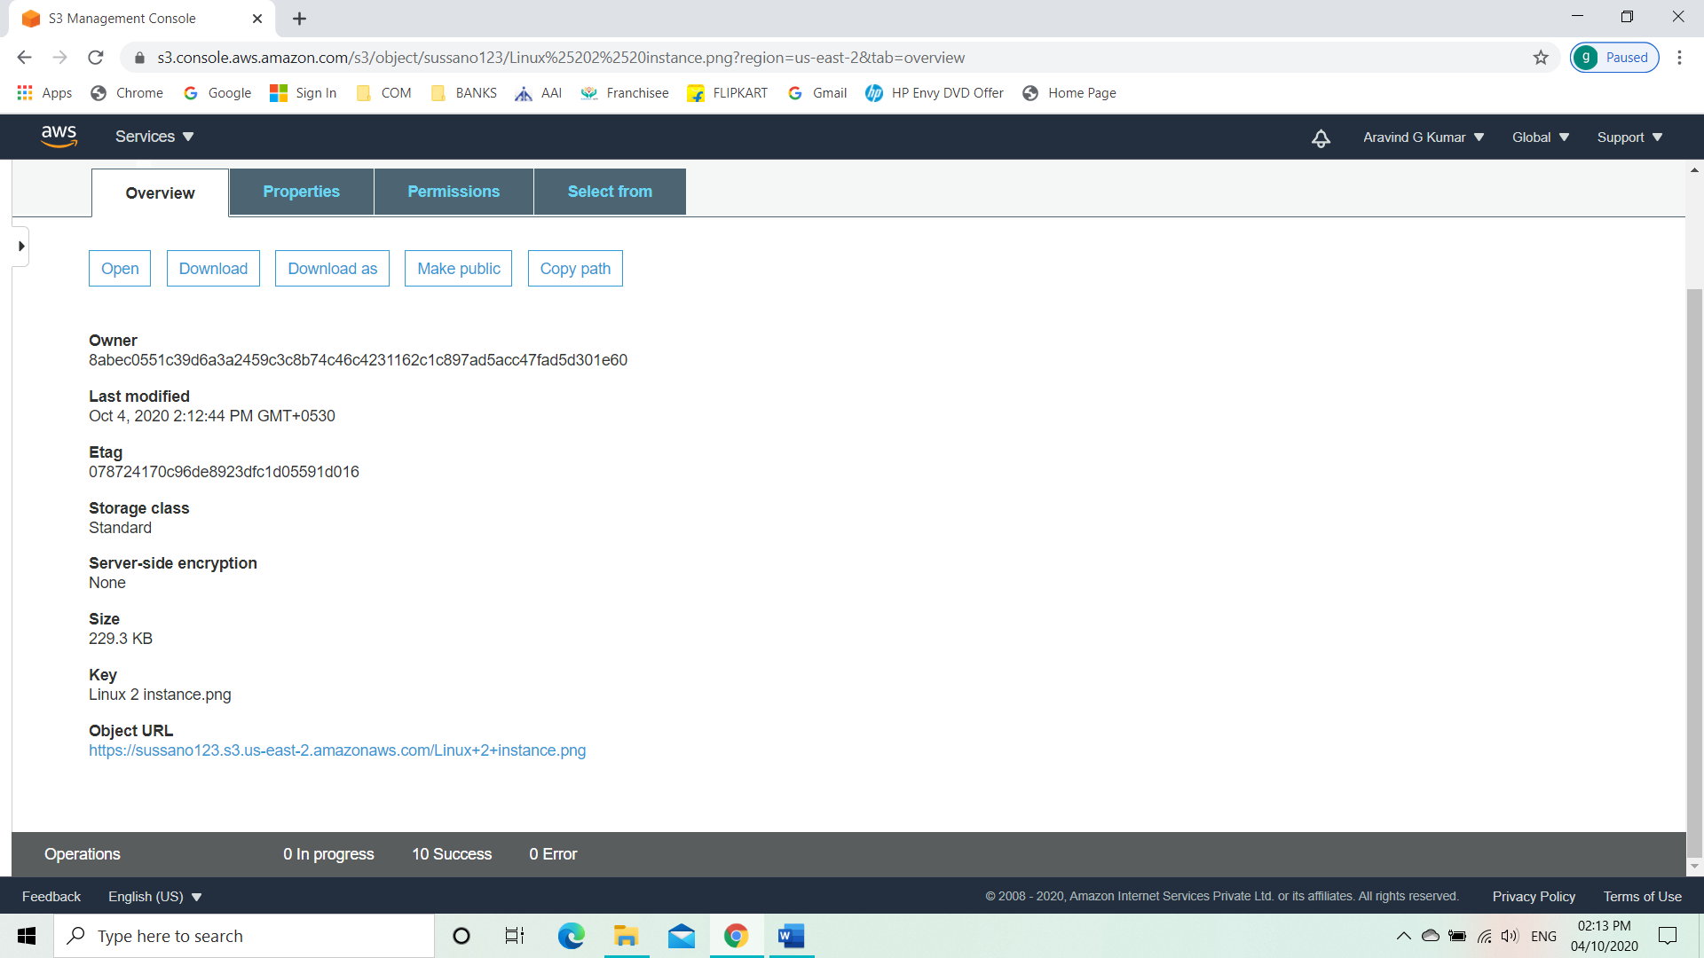

* After clicking on the object URL, we will see an error message meaning the bucket or the object isn’t made public.

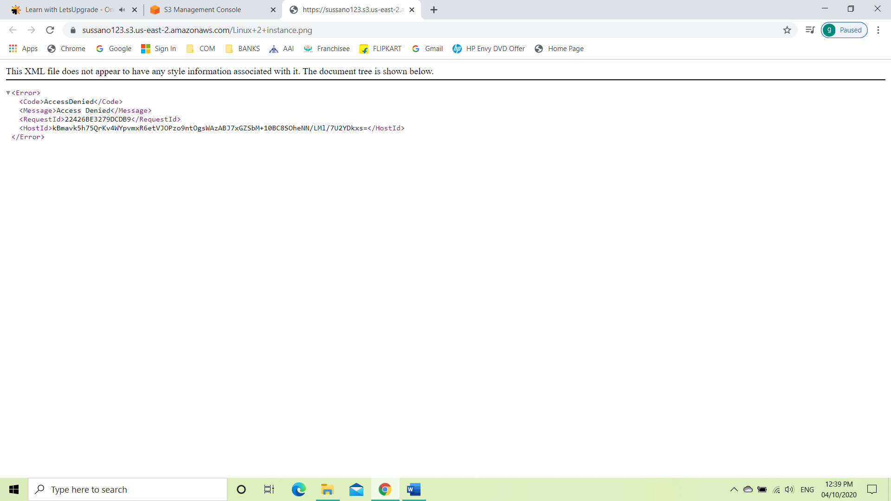

* Now make the bucket public by clicking on Permissions
* Then we will able to see Block all public access turned on.

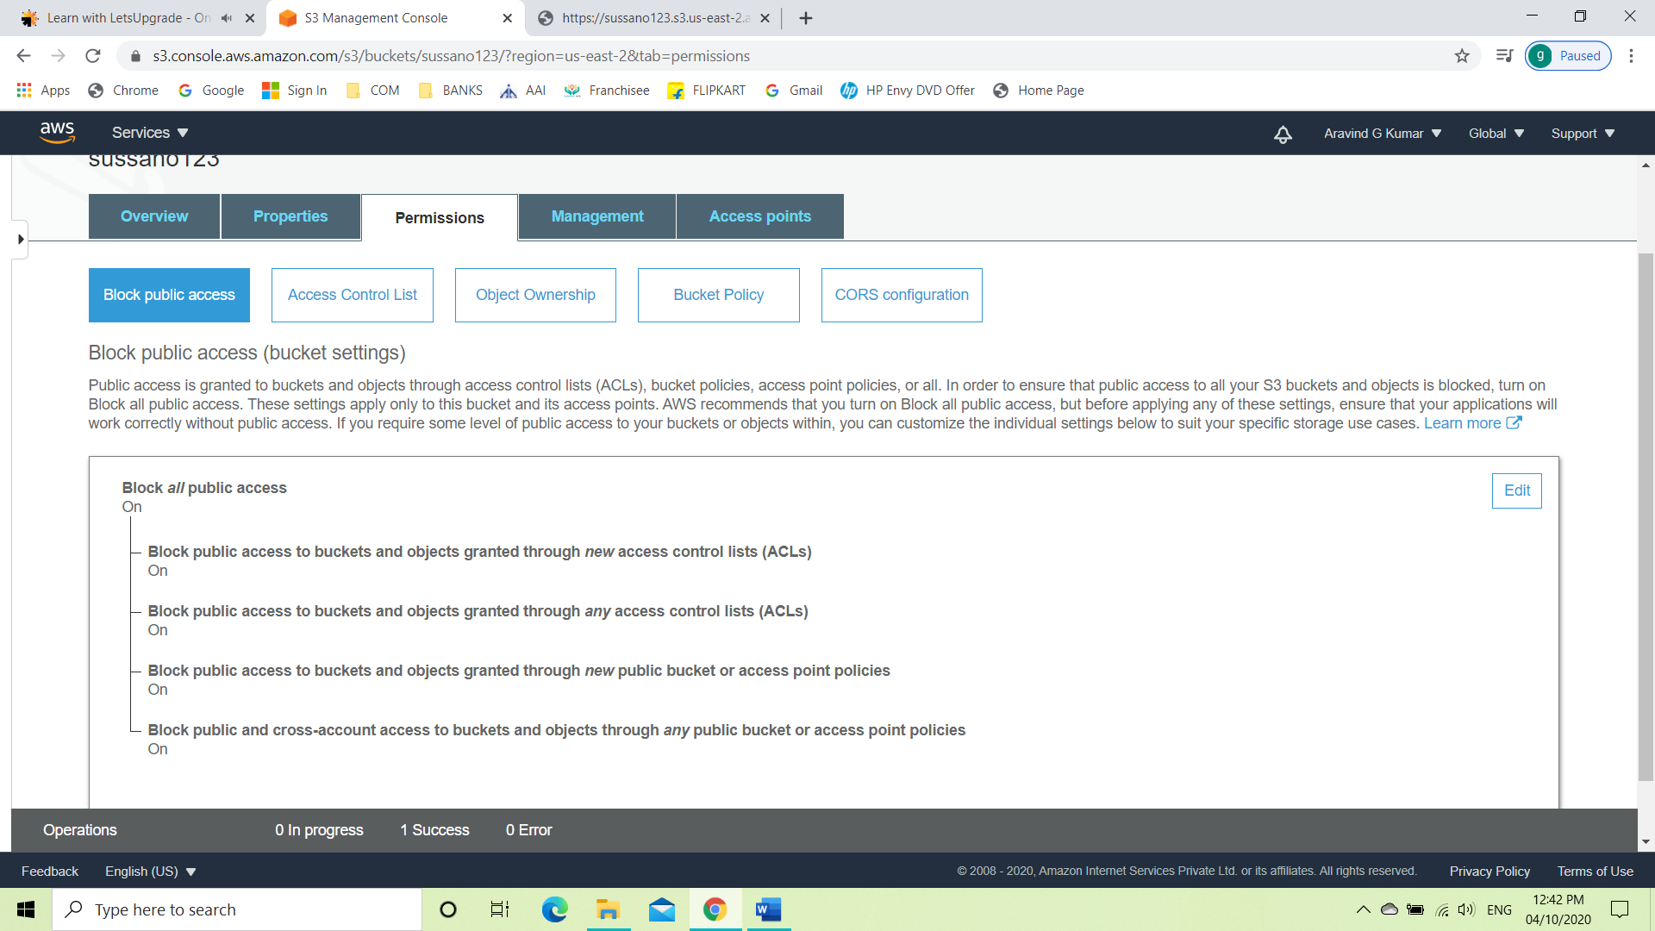

* Click on edit and uncheck the box.

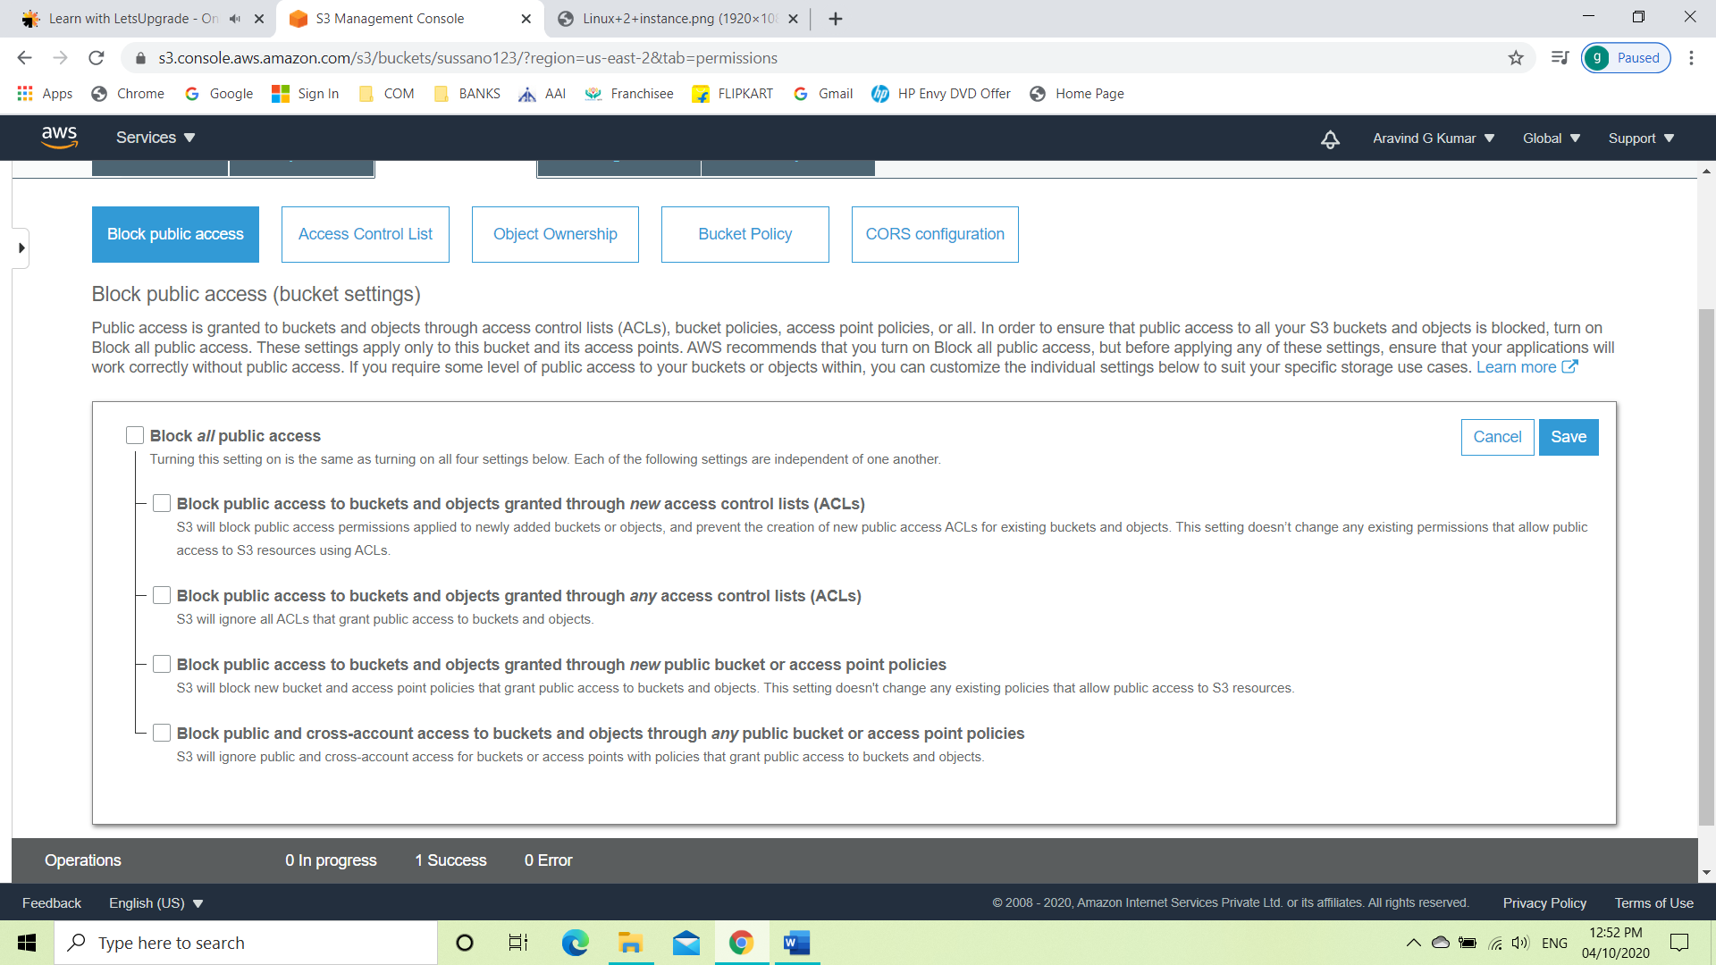

* Go to overview and click on object URL. As the bucket or object is made public and we can see the uploaded file.

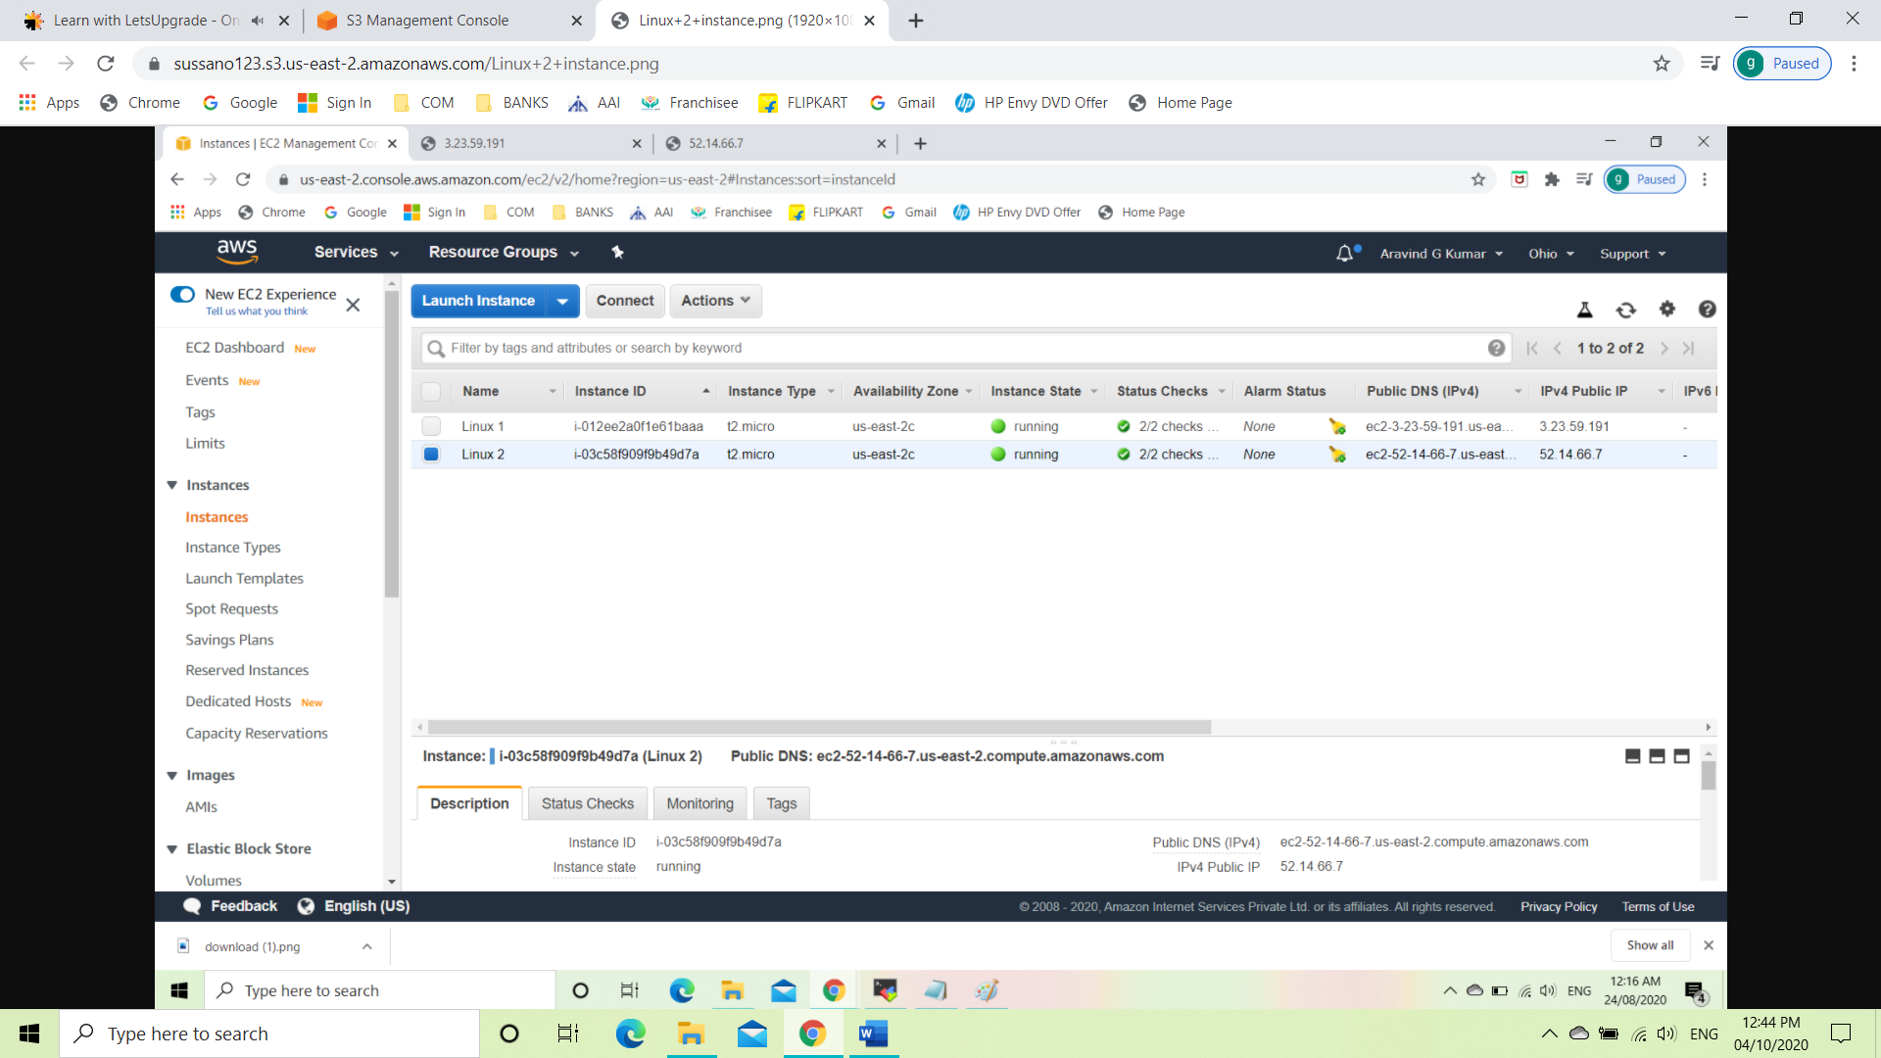

1. **Static Web Hosting**

STEP 1: Activating Static Web Hosting

* Click on the on the bucket and select properties.
* Select Static Web Hosting.
* Click on use this bucket to host a website and save it.

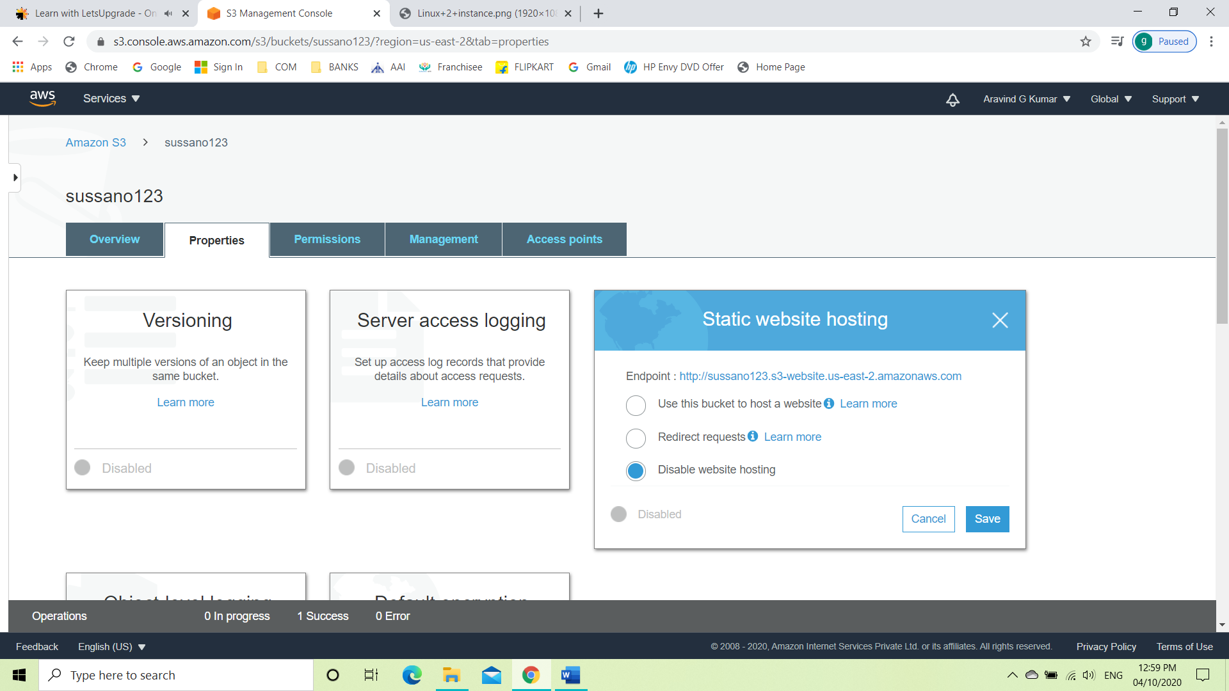

* Then create two text document named index and error.
* Write down the same name as of the saved text file on the index document and error document. E.g.: index.txt, error.txt.

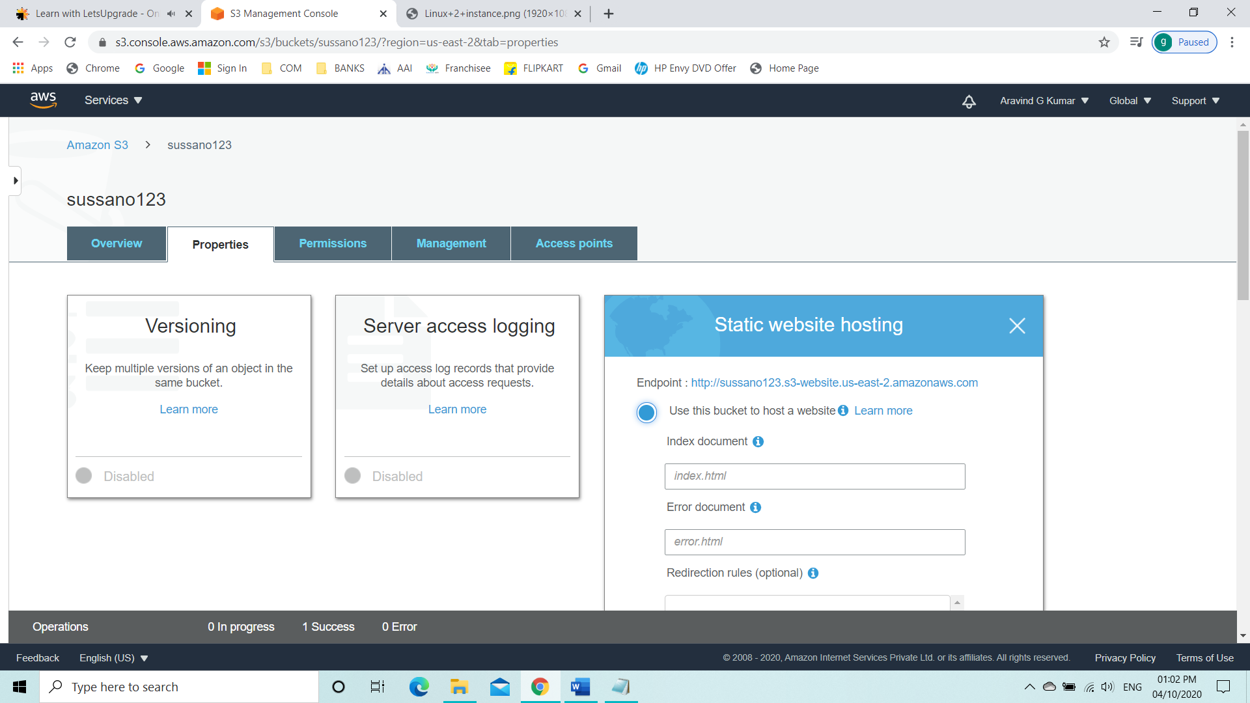

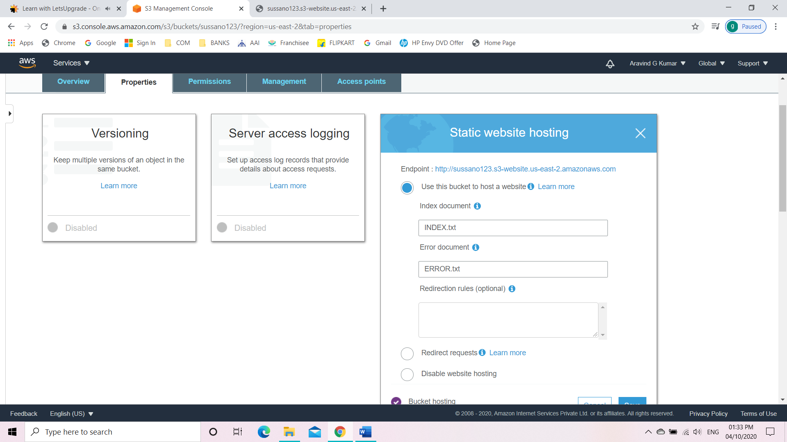

* Upload the two .txt documents into the bucket.

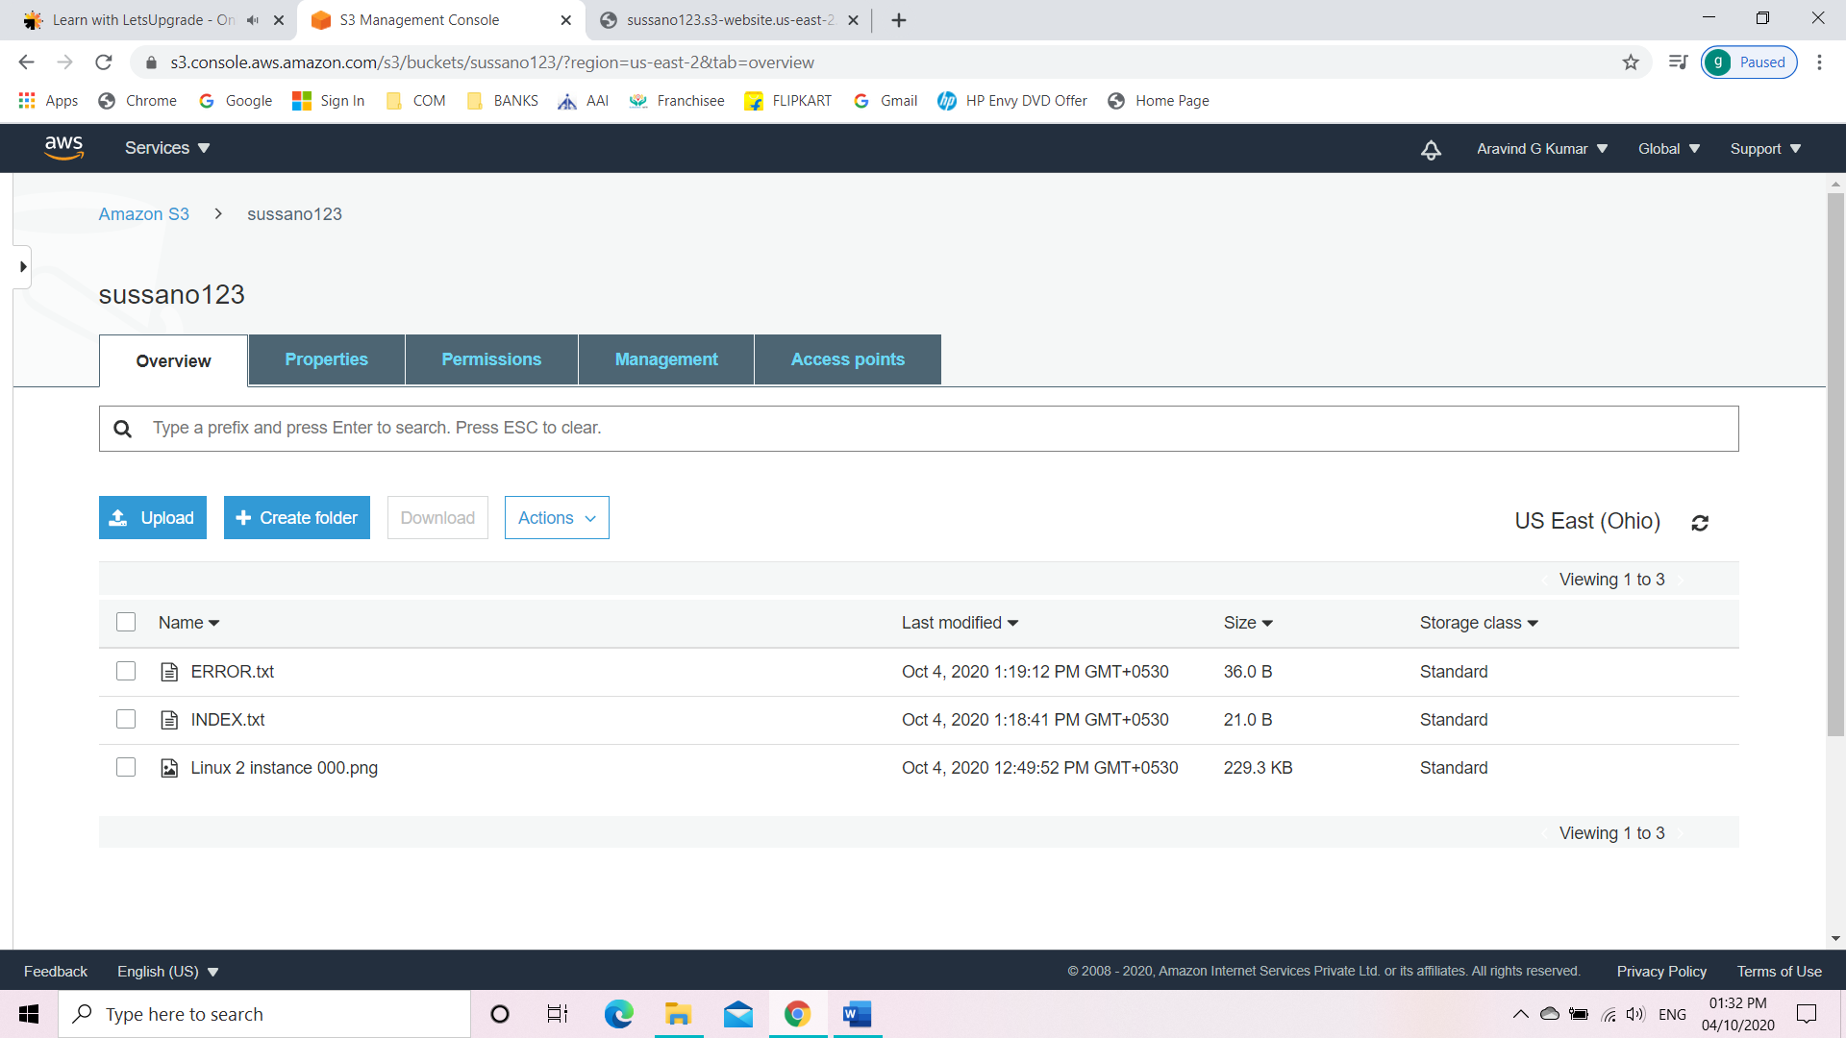

* Make both the uploaded files public.
* Click on the endpoint link to get redirected to the website.



**The launched web page with welcome message we gave in the text**

**file using static web hosting.**

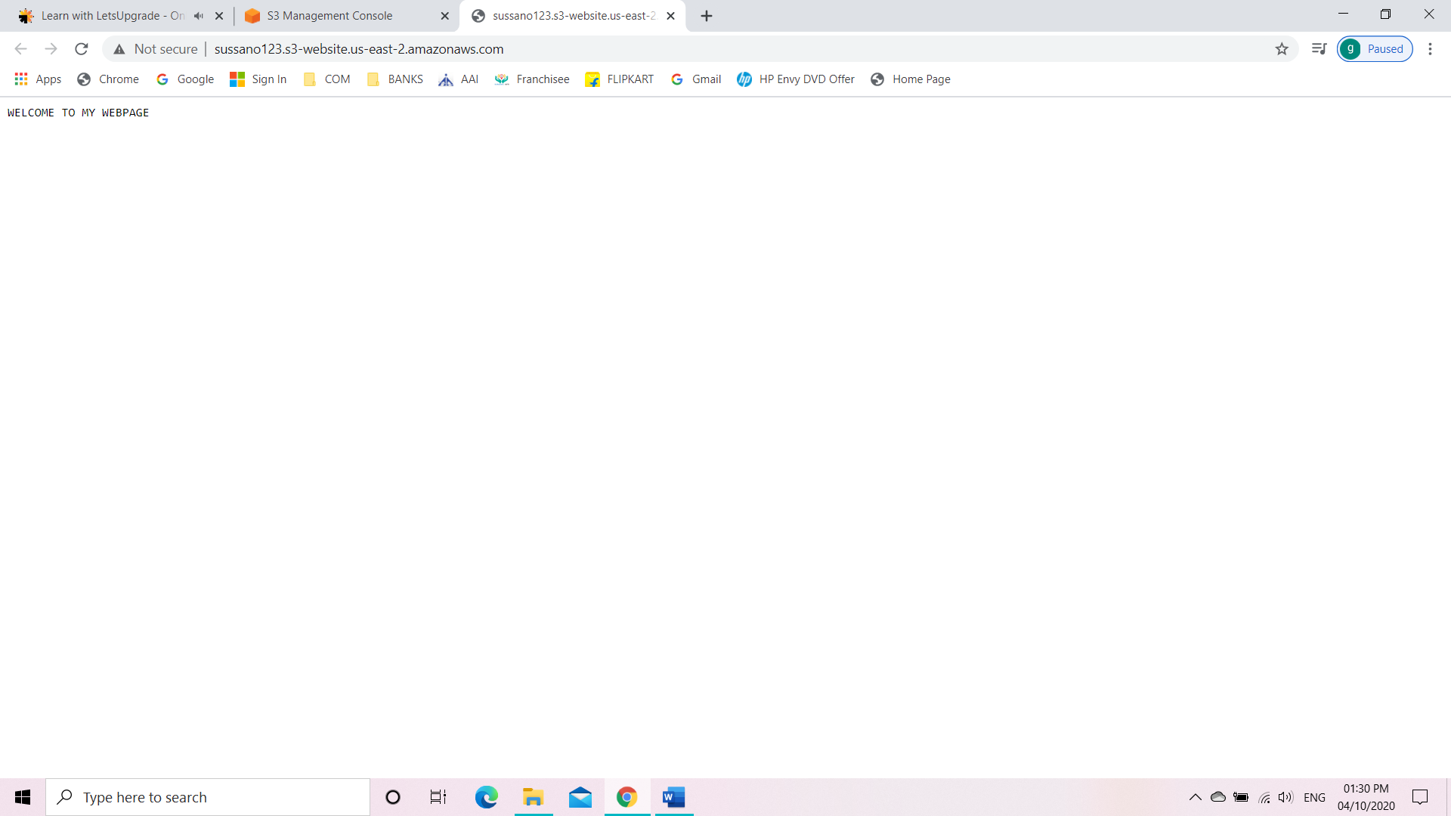

**The launched web page with the error message we gave on text file.**

**Make a mistake on the URL.**

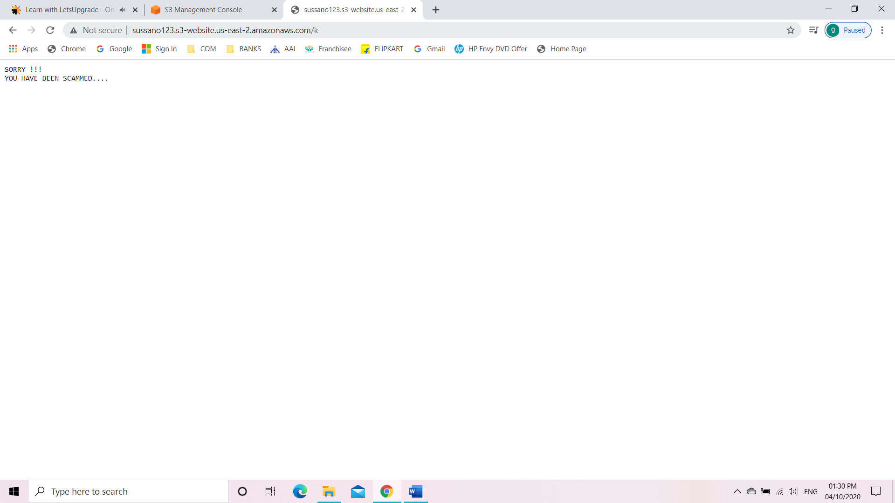

1. **Versioning**

STEP 1: Enable Versioning

To enable versioning:

* Create a new bucket.
* Go to properties of the bucket
* Click on versioning
* Enable it

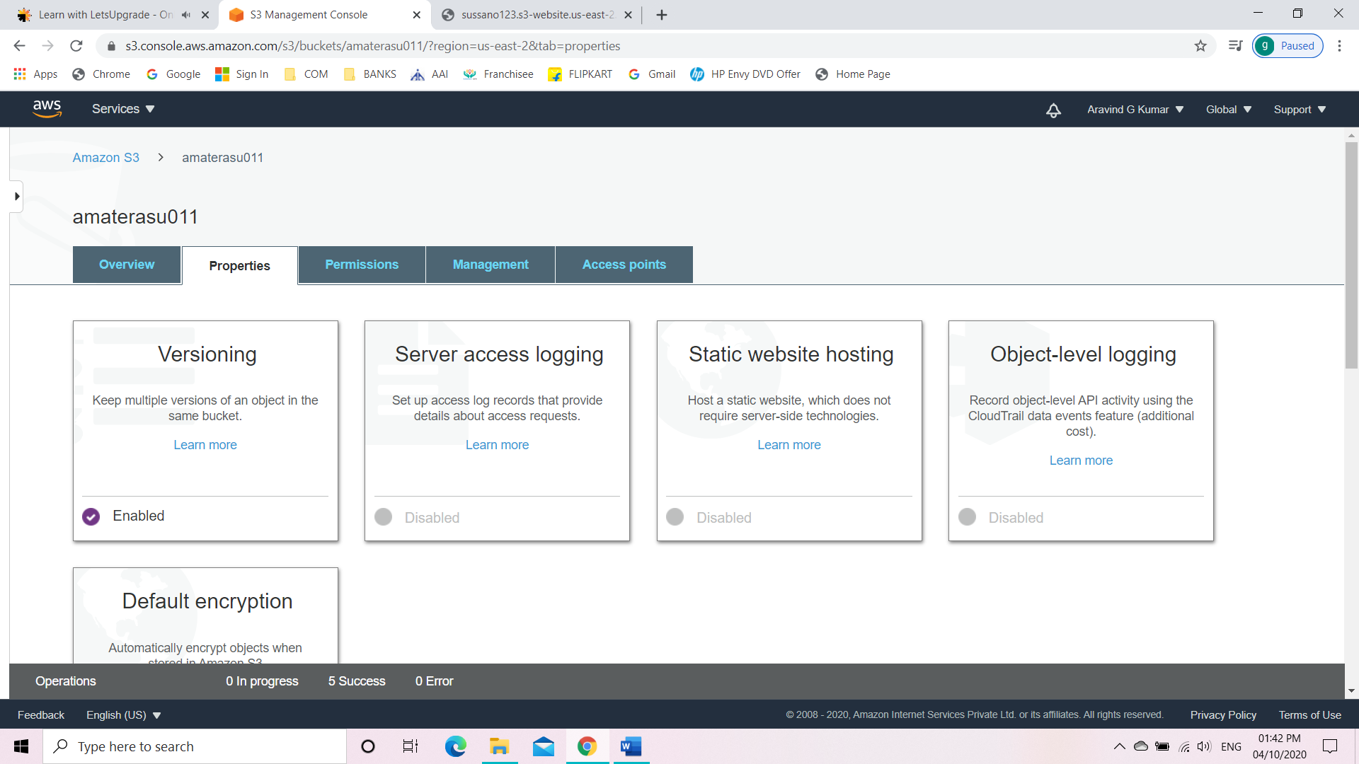

STEP 2: Upload a text file

Create a text file and upload that text file into the bucket.

E.g. versioning.txt

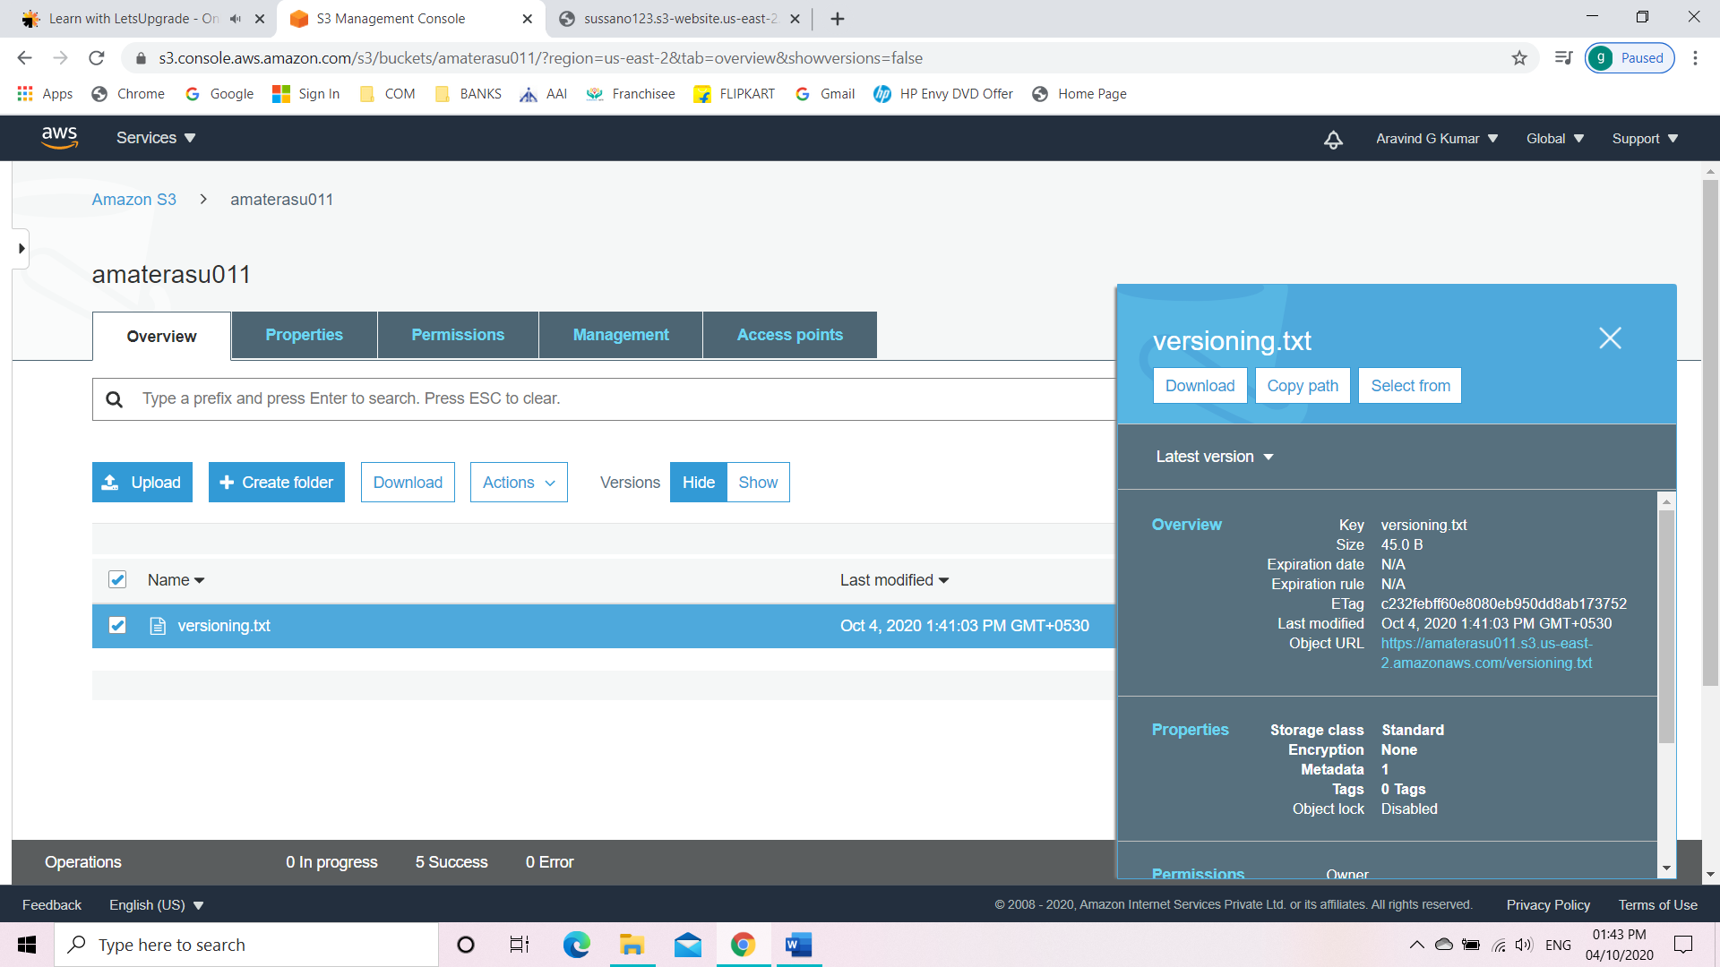

STEP 3: Edit the content

* Edit the content of the text file versioning.txt.
* Save the file without changing the file name.
* Then we upload the file again to the bucket.
* Now we can see a tab called hide/show versions.
* Click on show versions.
* Now we can see two different versions of the same file.

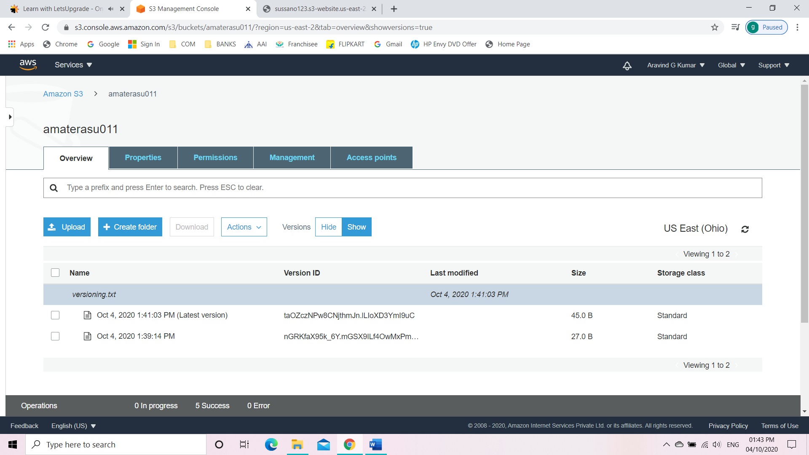

STEP 4: Deleting Uploaded file

* Hide the versions.
* Select the file and delete the file.

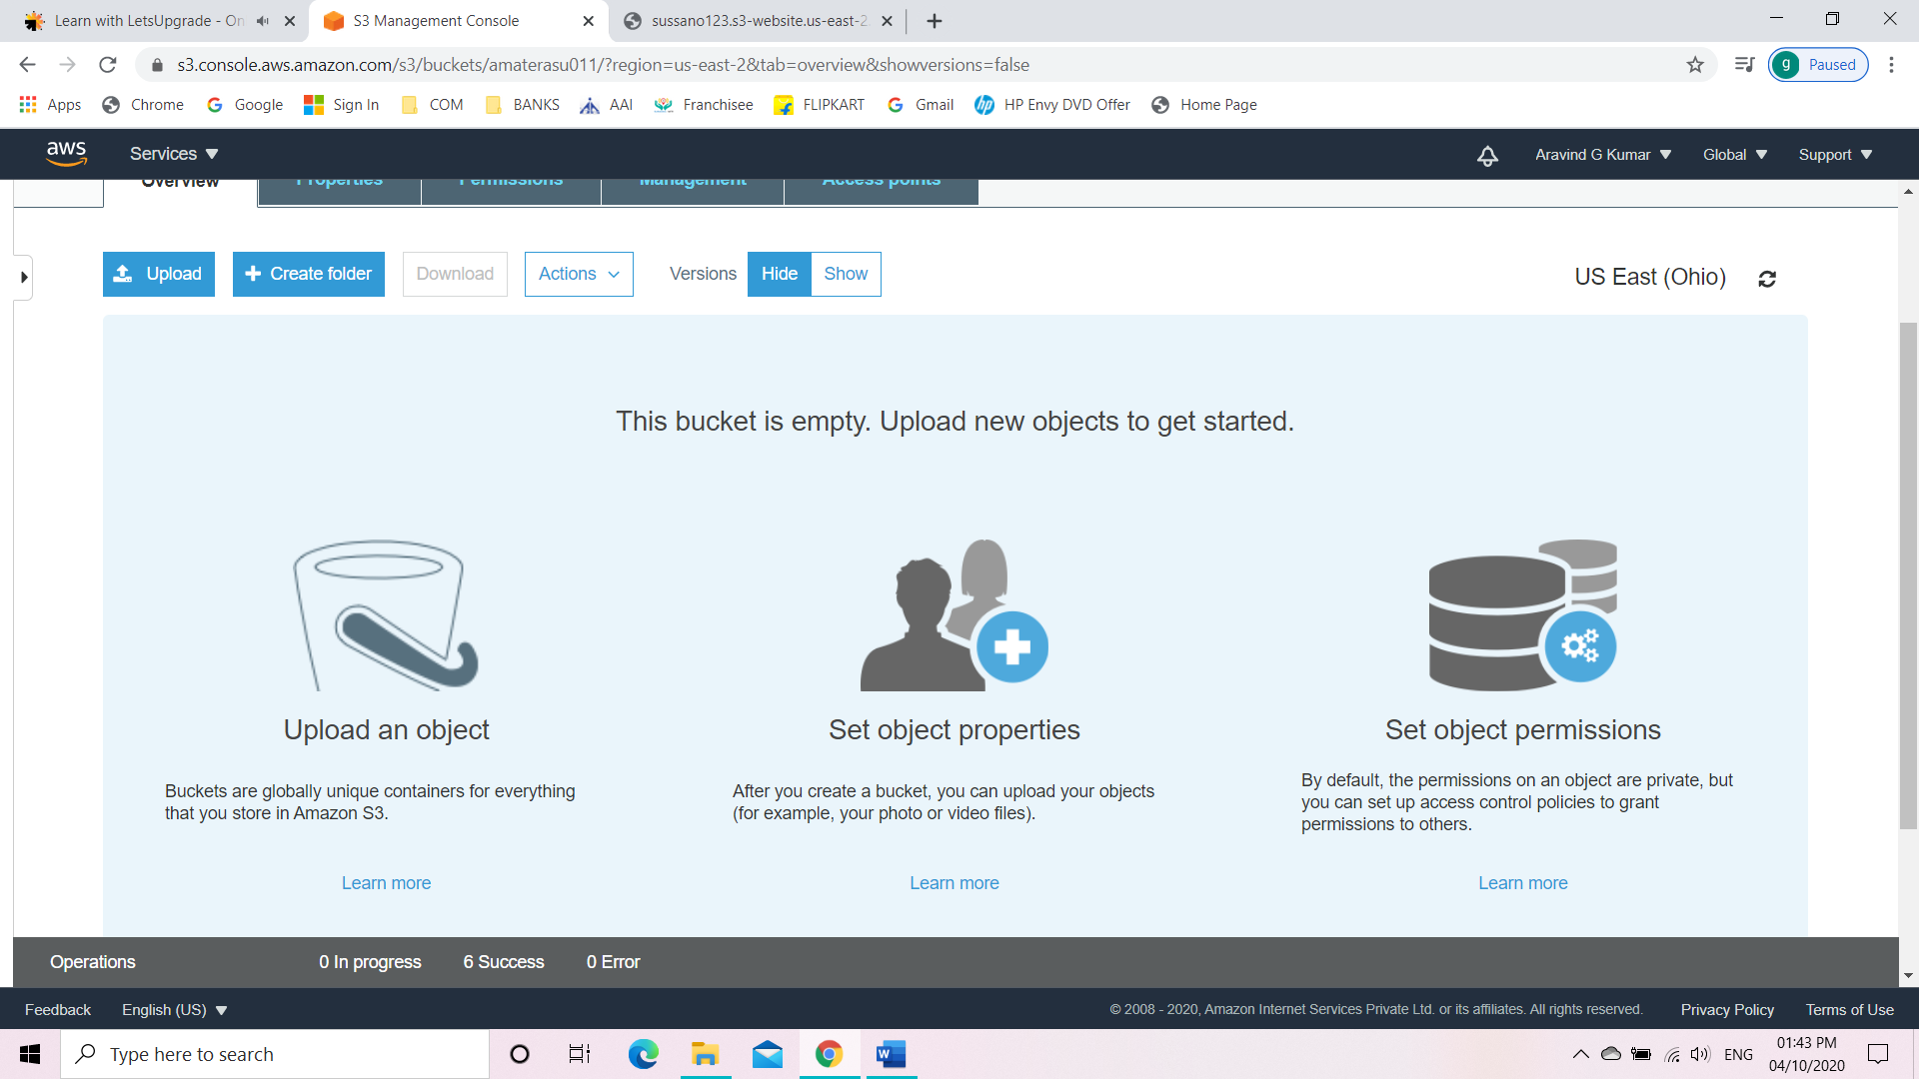

* Click on show versions.
* Now we can see the deleted version there.

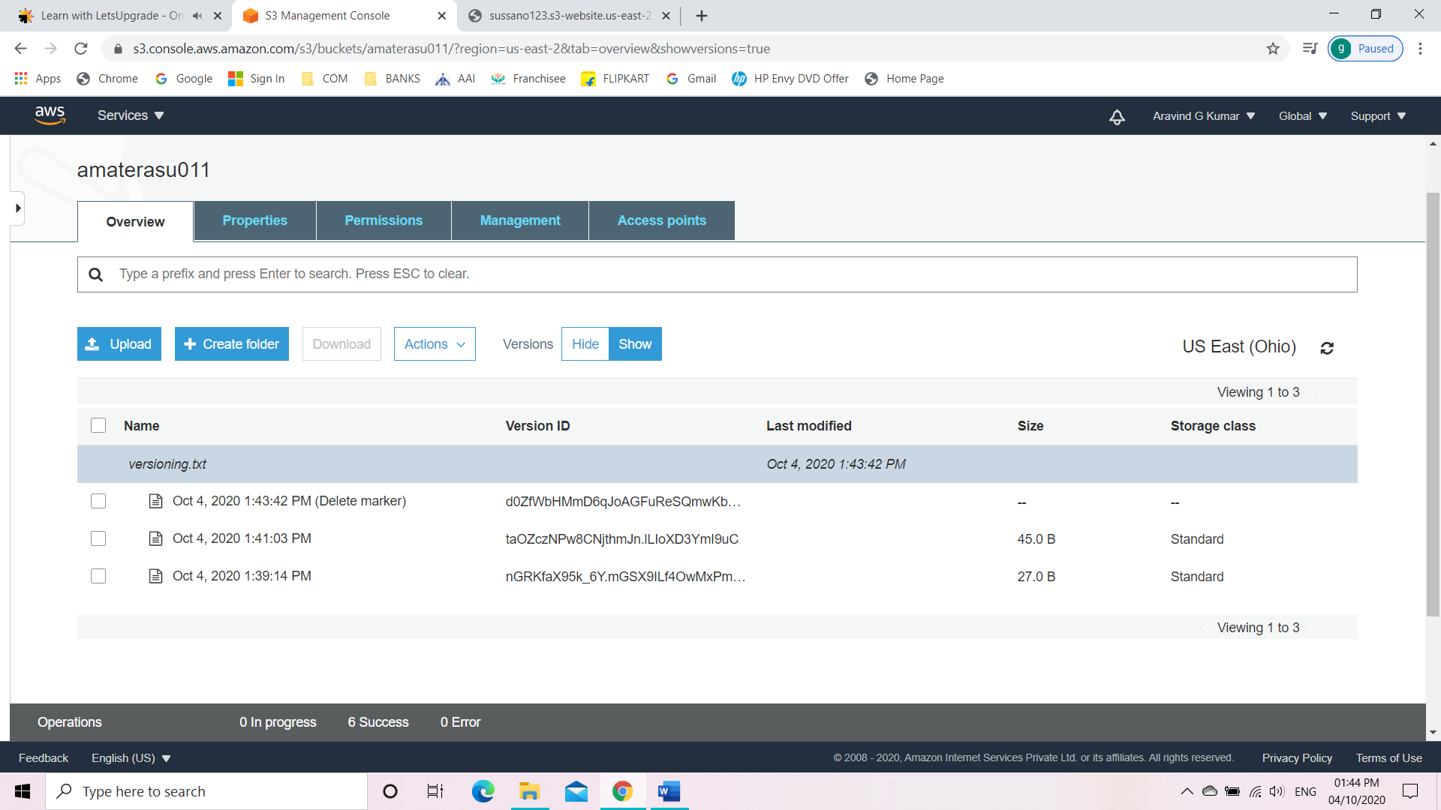

* Now download any version and upload it again.

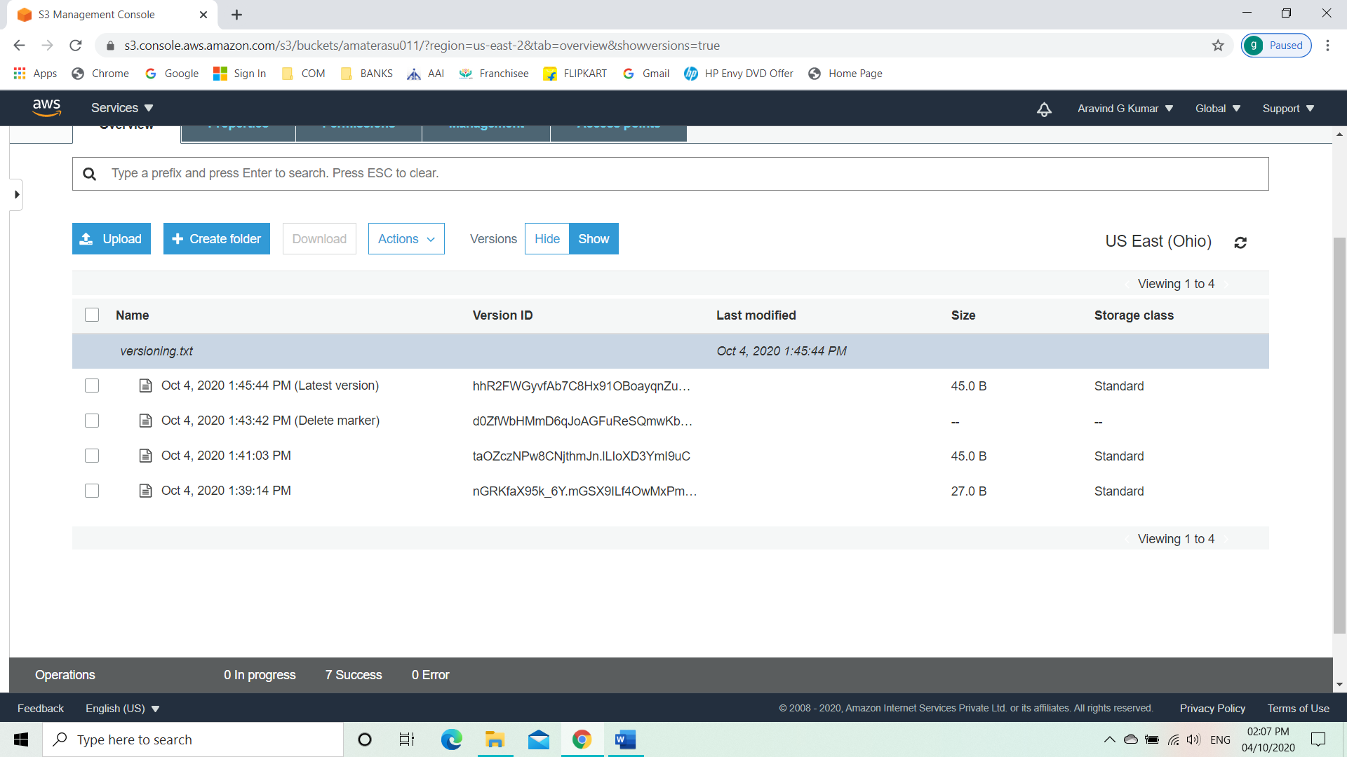

**Question**

Explain the life cycle effects on instances:

* Stop: After stopping the instance the connected server will be terminated and will be shown with an error message because the Public IPv4 has been released on to the shared pool. But the Private IP stays the same.
* Start: After restarting the instance the Public IPv4 has been changed and is assigned with a new Public IPv4. But the Private IP remains the same. The web server can be accessed using the newly assigned Public IPv4.
* Reboot: After reboot there wasn’t any change to the Public and Private IP. And the web server was available with the same Public IPv4.
* Terminate: When we terminate the instance the Public IPv4 and the Private IP both will be released into the shared pool. The launched application will also be terminated.